Lateral Load Path Analysis of Cross Laminated Timber Building with Rocking Wall Systems

Monica Liu
University of California, Berkeley

Natural Hazards Engineering Research Infrastructure,
University of California, San Diego:
Large High Performance Outdoor Shake Table

Faculty Mentor:
Professor Shiling Pei, Colorado School of Mines

Abstract
In spite of the increasing popularity of cross-laminated timber (CLT) within the construction industry and in the erection of tall timber structures, the full potential of CLT to be used in seismically resilient structures has not yet been realized. The following experiment studies a two-story, open floorplan CLT structure with rocking wall systems, which utilizes U-shaped flexural plates (UFPs), steel tongues, and post-tensioned bars in order to create a structure with self-centering capabilities. Specifically, the lateral load path of this system, which begins at the diaphragm and transfers loads through the steel tongues into the rocking walls, which subsequently transfers these forces into the UFPs and post-tensioned bars before reaching the steel beam foundation, is analyzed. Through the load cell data collected on the forces within the post-tensioned bars, and with the damage control inspection observations collected following various ground motion tests, the lateral load path of the structure was verified. Ultimately, this research and the improved understanding of the CLT system and its lateral load path contribute to the future establishment of a seismic design methodology for tall wood buildings.

Introduction
Cross-laminated timber (CLT) is a mass timber construction material that is comprised of an odd number of wood panels that are layered and glued with alternating orthogonal wood-grains in order to create a composite panel that possesses a greater ability to resist gravity loads than its individual components. CLT has already begun to change the way that engineers construct timber structures, by allowing for the design of taller timber buildings such as the Forte in Melbourne, Australia—a 10 story apartment complex. The benefits of CLT construction include the lightweight property of the material, as well as the ease of construction because of the ability to prefabricate the CLT panels. However, CLT is still limited in its performance as a construction material for earthquake engineering due to the fact that CLT is a stiff material and its ability to perform well under seismic loading is heavily dependent on introducing ductility through connections.
In this research, the potential of CLT to be used in seismic designs was tested, and the lateral load path within the structure was analyzed. A load path is the direction in which forces will be transferred through various members within a structure, beginning at the top of the building and ending at the foundation of the system. Rocking CLT walls located near the core of the structure served as the seismic force-resisting system within a two-story CLT structure with a concrete and timber composite roof. Post-tensioned (PT) bars were used to allow the CLT walls to return to their original configuration in the event of an earthquake. U-shaped flexural plates (UFPs) were fit in between two adjacent wall panels to dissipate energy. And steel tongues connected the diaphragms to the rocking CLT walls to allow the entire structure to move together during a seismic event. The benefit of this CLT structure’s configuration is the increased seismic resiliency of its structural design. Following an earthquake, the structure should return to its original centered state. The PT bars should have remained elastic, and the UFPs located between the rocking CLT wall panels can be easily replaced if damaged. Understanding the lateral load path of this system, and using experimental research to determine whether or not these elements behave as they are expected to during an earthquake, is necessary for discovering inefficiencies within the structural design and for identifying which areas can be improved on for future seismically resilient CLT structures.
Methodology
In order to understand the lateral load path for this cross-laminated timber structure, experiments were conducted at the University of California, San Diego’s Large High Performance Outdoor Shake Table at the Englekirk Structural Engineering Center. Below, the test specimen is described, as well as the earthquake ground motions and instrumentation that were used to analyze the lateral load path of the CLT structure. A basic sketch of the overall test specimen is shown in Figure 1.
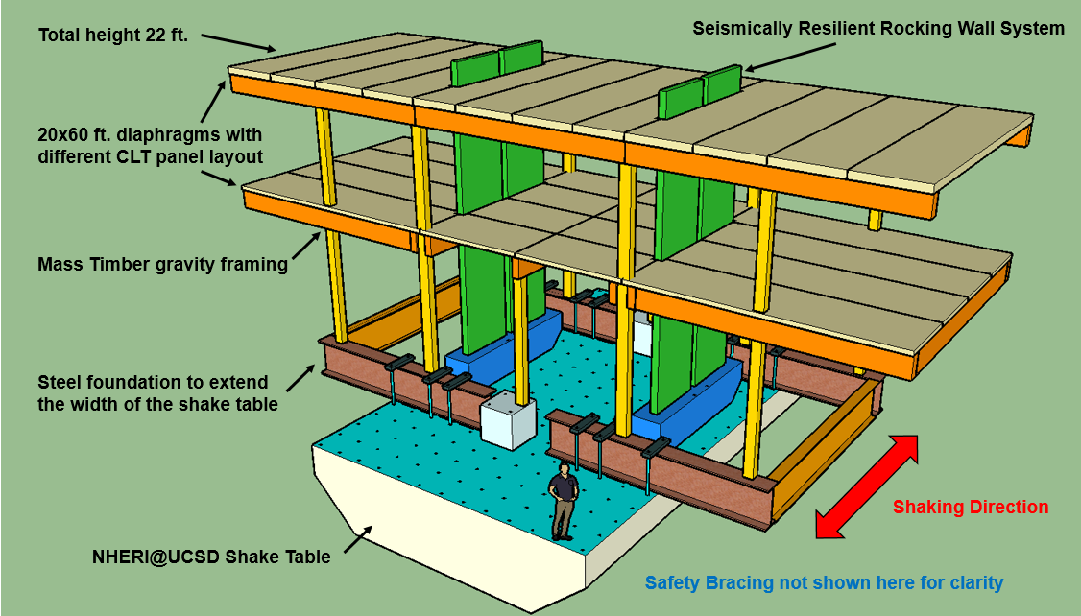
Figure 1: Schematic of CLT test specimen
Four rocking CLT wall panels were tested within a 22-foot tall, two-story CLT structure. Both diaphragms of the structure were 20 feet by 60 feet in area. The CLT diaphragm panels were all five-ply, Grade V1 timber. The first floor, which had an elevation of 15 feet from the base of the structure, had CLT panels which ran North to South—perpendicular to the direction of the ground motions. The second floor (roof) had CLT panels which ran East to West—parallel to the direction of the ground motions. In addition to the CLT panels on the roof, a 2 ¼ -inch slab of Type II/V concrete with a compressive strength of 5000 psi was poured on top, in order to create a timber-concrete composite diaphragm. Steel plates with a cumulative mass of approximately 90 kips were also secured onto the diaphragms to represent typical dead loads that would be experienced by a real wood-framed building of this size. The diaphragms were supported by glued laminated timber (glulam) beams of Grade 24F-V4 or 24F-V8. Subsequently, glulam, Grade L2 columns acted as the mass timber gravity framing for the open floor-plan timber test specimen.
Within the diaphragms, there were slots where the rocking CLT walls fit in to place. There were two rocking walls being tested in the structure, each of which was composed of two joined CLT wall panels. These panels were built out of CLT that consisted of five-ply, Grade E2-M1 timber, which were arranged such that the outermost layers of wood-grain ran vertically. The benefit of this formation is that, by orienting the outer layers parallel to the gravity loads, it maximized the rocking CLT walls’ load-bearing capacity. Each rocking wall panel was 5-feet wide and 24-feet tall. Two panels were placed side by side through the slots in the diaphragms, but were not rigidly connected to the steel beam foundation that they were placed on atop the shake table. U-shaped flexural plates (UFPs) were inserted in between adjacent panels to act as energy dissipation devices. The linear portions of the UFP were bolted to the panels, such that the two panels were joined to form the rocking CLT wall. As the wall moved the UFPs would deform to absorb the energy. The advantages of the UFPs are the simplicity of their design, the low fabrication costs, and the ease of installation and replacement [Baird et al., 2014].
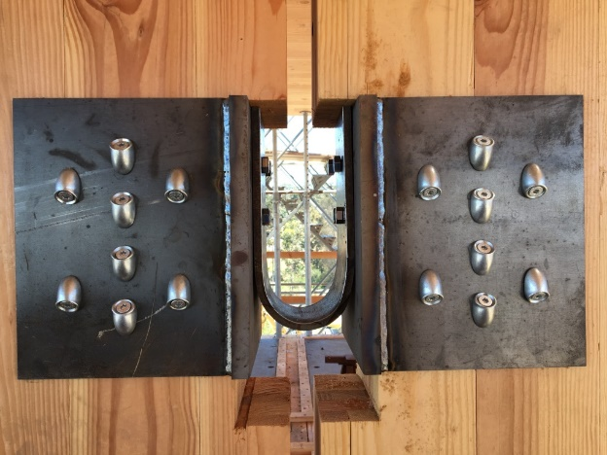
Figure 2: Installation of U-shaped Flexural Plates between two rocking CLT wall panels
The rocking CLT walls were then connected to the diaphragms using steel tongues. In order to create a more idealized, frictionless surface between the steel tongue and the rocking wall panels, thin Teflon plates were wrapped around the steel tongues. The steel tongues fit securely through slots in each of the rocking CLT wall panels at every level of the diaphragm and were then bolted onto steel plates that were then drilled into the diaphragms. With this configuration, the rocking CLT walls would move with the diaphragm during a seismic event.
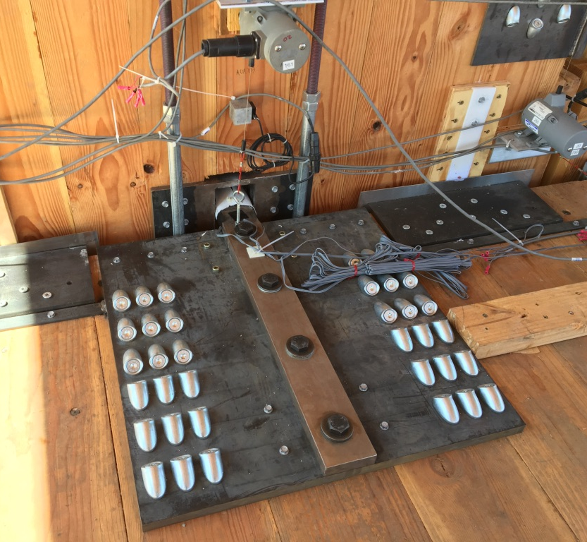
Figure 3: Installation of steel tongue connecting the rocking CLT walls to the diaphragm
To ensure that the structure returned to its centered state in the event of an earthquake, two post-tensioned (PT) bars were installed along both the North and South-facing planes of each rocking CLT wall panel and were threaded into and secured in place by steel plates that encompassed the tops of the walls and by steel blocks that were welded in place at the base of the walls [Conley et al., 2002]. Each of these PT bars were prestressed to 12 kips prior to the start of a new ground motion test, such that each wall panel was prestressed to 48 kips total. This prestressing would minimize the deflection of the walls during an earthquake.
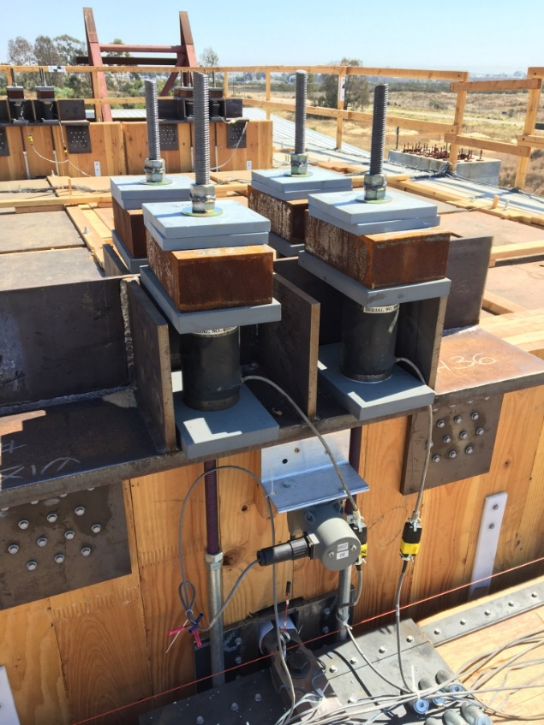
Figure 4: Installation of the four PT bars on each rocking CLT wall panel
Earthquake Count | Motion | Approximate duration
1 | Loma Prieta Strength Level Earthquake (SLE) | 100 sec
2 | Loma Prieta SLE | 100 sec
3 | Northridge SLE | 100 sec
4 | Superstition Hill SLE | 100 sec
5 | Northridge Design Basis Earthquake (DBE) | 100 sec
6 | Northridge 125%, Double –Public Test | 200 sec
7 | Imperial Valley SLE | 200 sec
8 | Northridge 125%, Double –Media Test | 200 sec
9 | Loma Prieta DBE | 100 sec
10 | Superstition Hill DBE | 100 sec
11 | Loma Prieta Maximum Considered Event (MCE) | 100 sec
12 | Northridge MCE | 100 sec
13 | Superstition Hill MCE | 100 sec
14 | Northridge MCE 120% | 100 sec
Table 1: Details regarding the ground motions run on the CLT test specimen
Several ground motions, as shown in Table 1, were run on the specimen in order to gain a holistic understanding of the structure’s behavior under various levels of seismic loading. During those ground motions, data was collected on the structure using instrumentation such as string potentiometers—which measure linear position and velocity, linear potentiometers—which measure linear displacement, accelerometers—which measures proper acceleration, strain gauges—which measure strain in an element, and load cells—which measure forces. Approximately 350 total instruments were placed at various points of interest throughout the structure. Load cells were used to measure the forces in each PT bar. Linear potentiometers measured the vertical displacement and uplift of the rocking walls, the relative displacement between the rocking wall panels, the displacement of the UFPs, slip between continuous CLT panels over glulam beams and at the spline locations in the diaphragms, and slip between the CLT panels and the concrete slab on the roof. String potentiometers measured shear deformation of the rocking wall panels, uplift and rotation of the walls, horizontal displacement between the wall panels and the diaphragm, displacement of the steel tongues with respect to the wall panels, and rocking of the columns with respect to the diaphragm. Lastly, accelerometers were placed throughout the walls and the diaphragms to monitor acceleration during testing.
It is important to note that, given the numerous organizations and parties involved in this research project, each with their own specific areas of interest—whether that be in the concrete and timber composite interaction, the structure’s diaphragms, or the rocking CLT walls—many of the instruments installed onto the structure were not necessary for the analysis of the CLT structure’s lateral load path. Specifically, by observing the forces in the post-tensioned bars, as well as by performing damage control reviews after different ground motion tests, it was possible to validate the lateral load path of the cross-laminated timber structure.
Lateral Load Path of the CLT System

According to the 2003 International Building Code (IBC), any system or method of construction to be used shall be based on a rational analysis in accordance with well-established principles of mechanics. Such analysis shall result in a system that provides a complete load path capable of transferring all loads from their point of origin to load-resisting elements. The presence of continuous load paths is therefore essential for designing any seismically resilient structure in order to avoid catastrophic damage to the system.
Earthquake ground motions induce inertial forces in structures where mass is present [Murty, 2014], and these forces must be transferred along the load path from the highest point of the system into the base. Therefore, the benefit of most wood-frame structures is the existence of numerous redundancies in the load paths. This is attributed to the abundance of structural elements and nail connections incorporated into the system, which ensures that forces will be transferred into the structure’s foundation.
Within the CLT test specimen being analyzed at the Large High Performance Outdoor Shake Table, the forces originated at the system’s diaphragms. It was assumed that there was a uniform distribution of mass across these diaphragms, despite the irregular pattern in which each floor was loaded with steel plates to replicate typical dead loads within a real, operating structure of similar properties. During earthquake simulations, the ground was accelerated, and this acceleration resulted in an inertial force within the diaphragms that could be approximated with Newton’s second law of motion by simply multiplying the dead load on each diaphragm by the experienced acceleration of that floor.
The force was then transferred into the steel tongues, which served as the rigid connection to transmit loads into the rocking CLT walls. The lateral forces that were directed into the walls caused the rocking CLT walls to experience an overturning moment once the lateral force exceeded the precompression force within the PT bars. This overturning moment could also be approximated very generally by multiplying the lateral force from the diaphragms by the perpendicular distance from the diaphragm to the foot of the rocking walls.
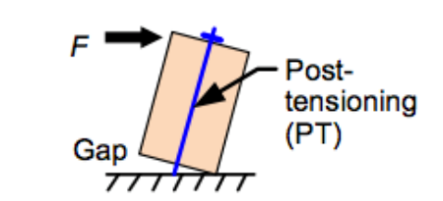
Figure 5: Gap opening mechanism which creates the elastic restoring force [Chancellor, 2014]

Subsequently, a gap was formed between the base of the rocking walls and the steel beam foundation that they rested on, and the decompression of the PT bars reduced the overall stiffness of the lateral force resisting system [Chancellor et al., 2014]. Given that the period of any structure is very roughly proportional to the square root of the structure’s mass divided by the structure’s stiffness, this loss in stiffness increased the structure’s overall period and thus minimized the magnitude of forces that could develop within the lateral force resisting system to damage the system.
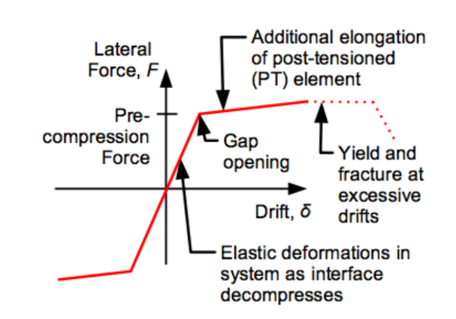
Figure 6: Restoring force associated with gap openings [Chancellor, 2014]

During this process, the UFPs that were bolted in between the rocking CLT wall panels deformed and dissipated energy. Following the removal of the lateral forces in the rocking walls, the post-tensioned bars experienced compressive forces that pulled the walls, and thus the overall structure, back to its original, vertical state [Chancellor et al., 2014]. And from the PT bars, the load was finally transferred into the steel beams at the base of the system.
Evidence and validation of this lateral load path should be seen in the data collected during the testing of the CLT structure, and in the damages observed following ground motion tests.

Results
Results for the testing of the CLT structure were obtained through both quantitative and qualitative means. Numerical data was collected on the responses of different structural components during the ground motion tests using the instrumentation described previously. In addition, experimental observations were documented during damage control inspections. Given the high volume of data and observations recorded across the 14 different ground motion tests, and the sensitivity and confidentiality of certain data collected, only the data and observations relevant to understanding and analyzing the lateral load path of the CLT structure are included in this report.
Damage control inspections were performed following different ground motion tests. During these inspections, observations were recorded about the level of damage sustained by various components of the cross-laminated timber structure, and about the performance and behavior of the test specimen.
Table 2 describes the major, observable damage states at the ground level of the CLT structure following the ninth and tenth ground motions, the Loma Prieta DBE and the Superstition Hill DBE, both of which had a duration of 100 seconds.
Test (#): | Location: | Description: | Documentation:
Loma Prieta/ Superstition Hills DBE (9, 10) | Wall Panel;  Ground;  South Bay;  South Face | Possible laminate separation East of center edge.
Loma Prieta/ Superstition Hills DBE (9, 10) | Wall Panel;  Ground;  South Bay;  South Face;  West Corner | Second and third laminate seams from west edge are separating. ~2 mm separation. | 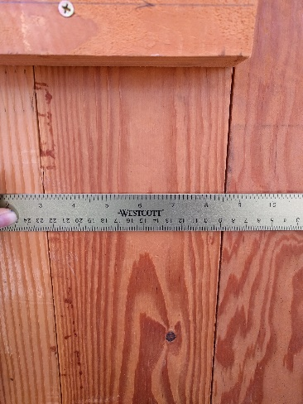
Loma Prieta/ Superstition Hills DBE (9, 10) | Wall Panel;  Ground;  South Bay;  South Face;  Mid Height | Wood splitting along inside corner of East Panel. ~ 15” split. | 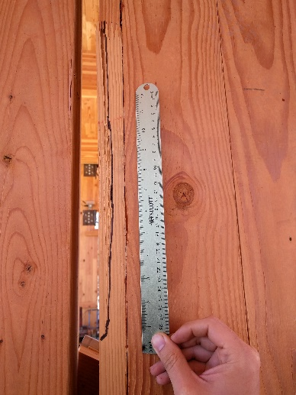
Loma Prieta/ Superstition Hills DBE (9, 10) | Wall Panel;  Ground;  South Bay;  South Face;  East Corner | 0.134” of crushing at east corner of base. | *No picture documentation
Loma Prieta/ Superstition Hills DBE (9, 10) | Wall Panel;  Ground;  South Bay;  South Face;  West Corner | 0.120” of crushing at east corner of base. | *No picture documentation
Loma Prieta/ Superstition Hills DBE (9, 10) | Wall Panel;  Ground;  Center Bay;  South Face;  East Corner | 0.098” of crushing at east corner of base. | *No picture documentation
Loma Prieta/ Superstition Hills DBE (9, 10) | Wall Panel;  Ground;  Center Bay;  South Face;  West Corner | 0.075” of crushing at east corner of base. | *No picture documentation
Loma Prieta/ Superstition Hills DBE (9, 10) | Wall Panel;  Ground;  North Bay;  North Face,  Mid Height | Laminate west of center separating, splitting at inside corner of wall, approximately one layer with split approximately 18” in length | 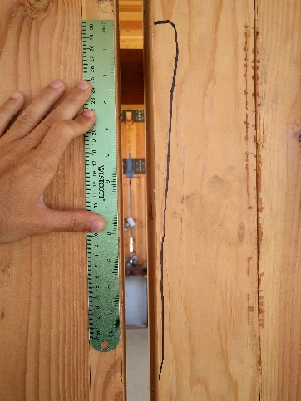
Loma Prieta/ Superstition Hills DBE (9, 10) | UFP;  Ground;  North Bay;  Lower UFP | Discoloration of UFP between bolts and at bottom of curvature.
 |  |  | 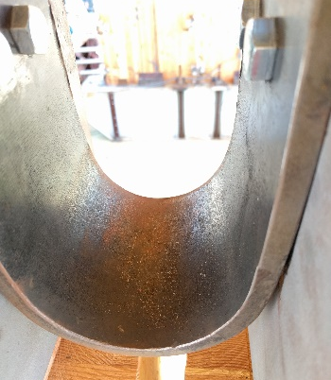
Loma Prieta/ Superstition Hills DBE (9, 10) | UFP;  Ground;  South Bay;  Lower UFP | Discoloration of UFP at bottom of curvature. Spider web pattern of strain on surface. | 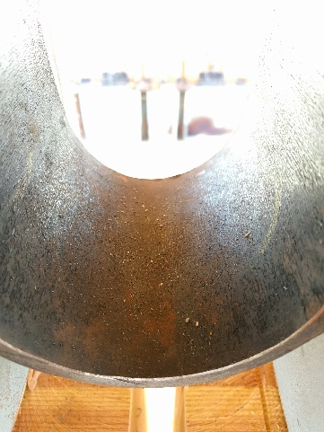
Table 2: Loma Prieta/Superstition Hills DBE damage inspection details for CLT structure at ground level

Next, Table 3 describes the major, observable damage states of the CLT structure at the floor level following the Loma Prieta and Superstition Hill DBE ground motions.
Test (#): | Location: | Description: | Documentation:
Loma Prieta/ Superstition Hills DBE (9, 10) | Diaphragm;  Floor;  Center Bay; North Side | Diaphragm displaced at Panel 3.
Loma Prieta/ Superstition Hills DBE (9, 10) | Diaphragm;  Floor;  Center Bay; North Side | Diaphragm displaced at Panel 4. | 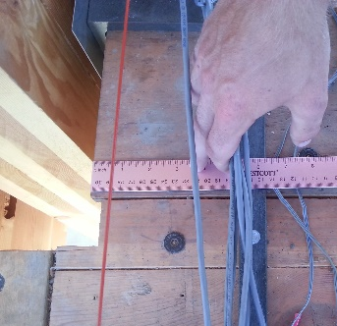
Loma Prieta/ Superstition Hills DBE (9, 10) | Diaphragm;  Floor;  Center Bay; South Side | Diaphragm displaced at Panel 2. | 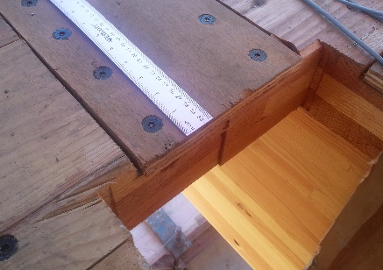
Loma Prieta/ Superstition Hills DBE (9, 10) | Diaphragm;  Floor;  South Bay; Center | Crack forming (traced in red) within diaphragm which originates from edge of rocking wall location and runs parallel to the wood grains, approximately 4 feet in length. | 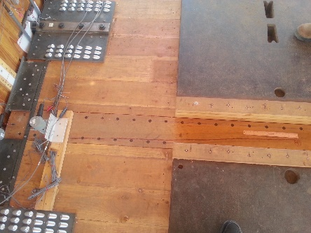
Loma Prieta/ Superstition Hills DBE (9, 10) | Diaphragm;  Floor;  Center Bay; South Side | Two cracks beginning at the west edge of spline, both approximately 6” in length. | 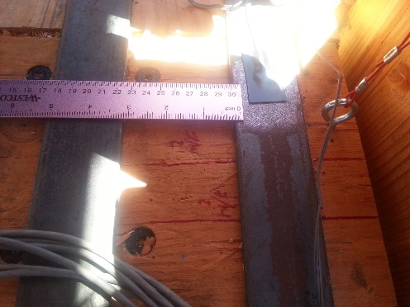
Loma Prieta/ Superstition Hills DBE (9, 10) | Diaphragm;  Floor;  South Bay | Crack forming within diaphragm on south edge, west of center spline | 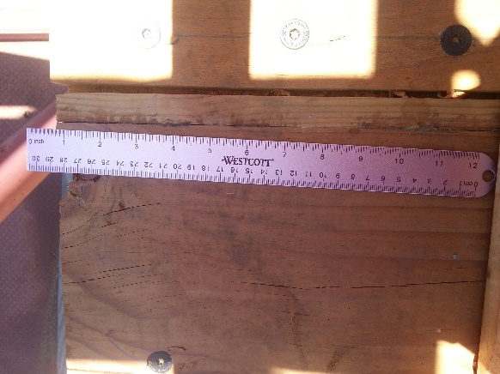
Table 3: Loma Prieta/Superstition Hills DBE damage inspection details for CLT structure at floor level
In addition to the damage control inspection observations, load cells collected data on the forces within the post-tensioning bars. Approximately two of the sixteen PT bars experienced a loss of tension during the final ground motion—the 100-second-long Northridge MCE 120% motion. Although the actual data collected during the test cannot be shown in this report for confidentiality purposes, the load cells recorded an initial value of approximately 12 kips, and a final value that was significantly lower.
Discussion
As described in Table 2 and Table 3 of the previous section, the majority of the damages recorded in the Loma Prieta/Superstition Hill DBE ground motion tests were sustained on the ground floor in the base of the rocking CLT walls of the structure. Ten damages were cited for the rocking walls at the ground level, while six damages were cited for the diaphragm at the floor level. Simply by comparing the number of recorded observations and the types of damages recorded, it is clear that the ground level absorbed more net force than the floor level of the CLT structure. Furthermore, while the displacement of CLT panels (shown in Table 3) at various locations in the floor level is evidence of the impact that the ground motions had on the diaphragm, a comparison of the condition of the diaphragm CLT panels to the rocking wall CLT panels indicates the difference in the level of force experienced by these two structural components. The CLT panels within the diaphragms, though displaced, remained relatively intact with signs of cracks in only three of the panels. In contrast, the CLT panels within the rocking walls showed significantly more evidence of damage in the form of delamination, cracks, and base crushing. This phenomenon is in accordance with the described lateral load path of this system, where the loads should ultimately be transferred away from the diaphragms and into the base of the structure through the rocking CLT walls.
Additionally, the observations made for the U-shaped flexural plates and the discoloration of these steel connections implied that the UFPs were close to their ultimate yield stress. The near yielding of these connections between the rocking CLT panels indicated that they were indeed dissipating energy from the system. By comparing the damage control inspection results between the ground level and floor level, the lack of recorded damages or discoloration for the floor level UFPs indicated that the lateral load path transferred the forces downwards through the rocking walls towards the foundation of the system. Therefore, the UFPs located closer to the base exhibited greater signs of stress.
Finally, the loss of tension recorded within the post-tensioning bars is indicative of yielding in the steel members. In the 14th ground motion, two of the PT bars experienced the upper limit to the magnitude of forces that they could endure prior to permanent deflections. This is evidence of the forces that were transferred through the PT bars and into the steel beams at the system’s foundation. While all other structural components of the system were not tested to the point of yielding or failure, the PT bars were the only members that reached their ultimate yield stress and would have needed to be replaced for further ground motion tests to continue, which indicates the high level of force that these members had to transfer within the lateral load path.
The lateral load path of the CLT structure studied in this report was such that forces originated at the diaphragm and were transferred into the rocking CLT wall panels through steel tongues. These forces were then transferred into the UFPs and into the PT bars in order to arrive at the steel beams which grounded the entire system to the shake table. The minimal cracking within the diaphragm CLT panels, along with the crushing, delamination, and cracking experienced by the rocking CLT wall panels, was validation of the lateral load path of the CLT structure and the transfer of lateral loads from the diaphragm into the walls. The discoloration of the UFPs at the ground level was evidence of the increased forces experienced at the base of the walls. Lastly, the yielded PT bars were proof of the final transfer of loads through the steel members into the foundation of the system.

Acknowledgements
I would like to thank my faculty mentor, Professor Shiling Pei from the Colorado School of Mines, for his guidance and mentorship during the research process, and Darren McKay, Associate Development Engineering Supervisor at UCSD’s Powell Labs, for his patience and for everything that he has taught me about experimental research and field work. Special thanks to Joycelyn Ng, Syed Ali Hasan, and Yun-An Lin for their constant support through it all! Finally, a big thank you to the Natural Hazards Engineering Research Infrastructure and the National Science Foundation, as well as the University of California, San Diego, for funding this project and making this experience possible.

References

Baird, A., Smith, T., Palermo, A., and S. Pampanin. “Experimental and numerical Study
of U-shape Flexural Plate (UFP) dissipators.” New Zealand Society for Earthquake
Engieering Conference (2014).
Chancellor, N. B., Eatherton, M. R., Roke, D. A., Akbas, T. “Self-Centering Seismic Lateral
Force Resisting Systems: High Performance Structures for the City of Tomorrow.”
Buildings 4.3 (2014): 520–548.
Conley, J., Sritharan, S., and M. J. N. Priestley. “Precast Seismic Structural Systems
PRESSS-3: The Five-Story Precast Test Building Vol. 3-5: Wall Direction Response.”
Precast/Prestressed Concrete Institute (2002).
Ganey, R. S. Seismic Design and Testing of Rocking Cross Laminated Timber Walls. Thesis.
University of Washington, 2015.
International Building Code, 2003. Country Club Hills, IL: International Code Council, 2004.
Murty, C. V. R. “Why are Load Paths Important in Buildings?” IITK-BMTPC
Earthquake Tips (2014).
Pei, S., and J. W. van de Lindt. "Seismic numerical modeling of a six-story light-frame wood
building: Comparison with experiments." Journal of Earthquake Engineering 15, no. 6
(2011): 924-941.
Van de Lindt, John W., Shiling Pei, Steven E. Pryor, H. Shimizu, and H. Isoda. "Experimental
seismic response of a full-scale six-story light-frame wood building." Journal of
Structural Engineering 136, no. 10 (2010): 1262-1272.

