Resiliency of Cladding Systems for Multi-Hazards

Melody Trejo

Spencer Quiel

Lehigh University ATLSS Engineering Center

California State University, Fullerton

ASCE

Abstract
Unexpected blast loading on structures result in damage causing economical stress, public safety hazards, and an extended time frame for reconstruction. Structures lacking the resilience for blast loads are vulnerable to profound damage. With Dr.Quiel leading the study, Lehigh University’s ATLSS, Advanced Technology for Large Structural Systems, laboratory is the location for the current research on resiliency of cladding system for multi-hazard. The purpose of this paper is to report the testing of flexible connections between cladding systems and the floor diaphragm for three structures varying in heights. The goal is to obtain mitigation from the flexible connections. The advancement of safer, more durable structures, can ultimately lead to a decline in the consequences followed from structures built less resilient. The results of testing are described in the paper and demonstrate the effects of flexible connections adapted.
Introduction
Throughout history structures have experienced unexpected blast hazards, whether during a terrorist attack, an explosion of chemicals in a factory, or other unpredictable circumstances. Nevertheless the uncertainties during blasts make predicting the aftermath of the damage incredibly difficult. Consequences resulting from blasts are measured in the amount of economic stress resulting from damage, the time to repair, and the public’s safety in or near the structure. Although the idea of a structure being fully resilient to an unexpected blast is unfeasible, structures that are less resilient to blasts create prolonged consequences in damage. This damage includes, but is not limited to, risking overall public safety, recovery time, and burdening the community’s economy or social norm.
Thus researchers have developed the question, can a structure be made more resilient by changing its design factors and cladding flexibility? There are many ways that these factors can be altered and tested, but it is a question of which is best to reduce all the negative consequences resulting from blasts while still remaining economical for both construction and the public. Historical events such as, the “1994 Northridge earthquake, the 1995 Oklahoma City bombing, and the terrorist attacks of September 11, 2001” where blasts have led to catastrophes have prompted researchers to merge developing knowledge focused on general consequences of failing structures during a blast and the actual engineering/design of these structures [2]. The idea is, that by decreasing the amount of damage done to a building during a hazard, the public avoids greater costs of repair and decreases safety hazards. However, past work is difficult for engineers to adapt to practice because data cannot fit engineers and designers practical needs, but instead does act as a building block for the end goal [1]. Also these equations were created to consider all possible hazards such as wind, earthquake, and blast.
On the other hand, this research is based on the outcomes from blast hazards. The purpose of this research is to answer which method is most effective to make structures more resilient during a blast. This should increase public safety, a structure’s ability to withstand a blast, and to reduce overall economical burdens following the blast. This will be tested on three different structures with heights of 4, 9, and 24 for further validation. The testing of different designs and cladding flexibility on structures will assist in disclosing what most increases a structure’s resiliency.

Methodology
To test the new framework and most current methodology from the research, software such as SBEDS for testing, SAP2000 for modeling and design, Open Sees for developing finite elements, and a basic understanding of the proposed framework flow chart Fig.1 below is required. Understanding the stiffness and strength of a material is vital to understanding how the structure will react to unexpected blast loads. In this case, steel is what really needs to be understood. The process of developing and working with finite element models to comprehend the bending of the nonlinear response of cladding that only bends in one direction is a part of the methodology in strengthening structures. This is looked at during the circumstance of a blast load. Testing different parameters is also important to understand what will ultimately increase resiliency. By doing this we understand the error behind some of the designs created and it leads research in the right direction. This methodology really focuses on improvig the design of the structure and ensuring its strength after almost every step in the desin process. During a blast load consequences are inevidble, we can only hope to limit the amount of consequences resulting from it. Therefore, there is a list of consequences that are lable as acceptable during a blast load and the new frame work considers these acceptable consequences constantly. Whereas, the older methodology only tested for these consequences at the end of the design of the structure and if the acceptable consequences had been exceeded then one would have to restart the entire design process. This method is more productive and strives for efficieny the first time around.
Fig. 1 [2] 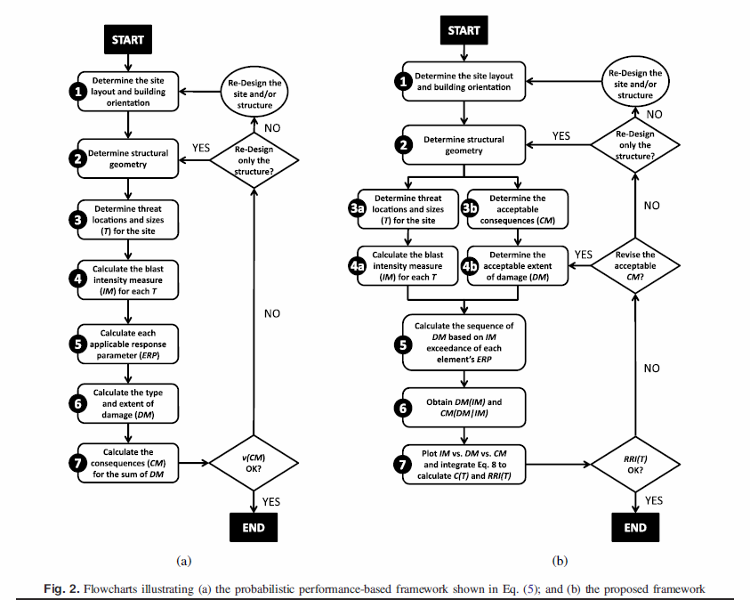
Results
The testing of flexible connections between cladding systems and the floor diaphragm for three structures varying in heights is what the results of our research are based on. The issue and goal in mind was to reduce the amount of damage caused by a structure during an unexpected blast load. By doing so, we reduce the time to reconstruct, economic stress, and increase public safety too. This is where the flexible connections assist in lessening any multi-hazard anticipated from a blast load. Although this research specifically focuses on blast load hazards, it has the potential to be applied to other natural hazards such as earthquakes and wind. The results of our most recent testing confirms that the flexible connections do in fact improve the resiliency of structures during unexpected blast loads, this concept has been tested by previous researchers. However, the extent of how much is still yet to be tested because our information is based on only numerical results and therefore cannot be completely accepted thus far. When the future testing of the research is conducted, a precast concrete panel design on SBEDS should be completed that will serve as a component in a shock tube test. Throughout the testing phase, it is ideal to have a low force transmissibility so that in return the structure experiences less force during a blast. By experiencing less force because of the flexible cladding, it withstands more force with less damage. This concept is the foundation for our entire research and thus far has been numerically confirmed. The figures below are prototypes that used during the analysis phase of this research. It is important to have analysis as accurate as possible because testing is expensive and takes many months of planning. To make the most of testing, we use analysis that has the most probably chance of being accurate and demonstrates the magnitudes we should aim for. Furthermore, we test many combinations to find the most successful ones like the ones below that are combinations that we tested for analysis.
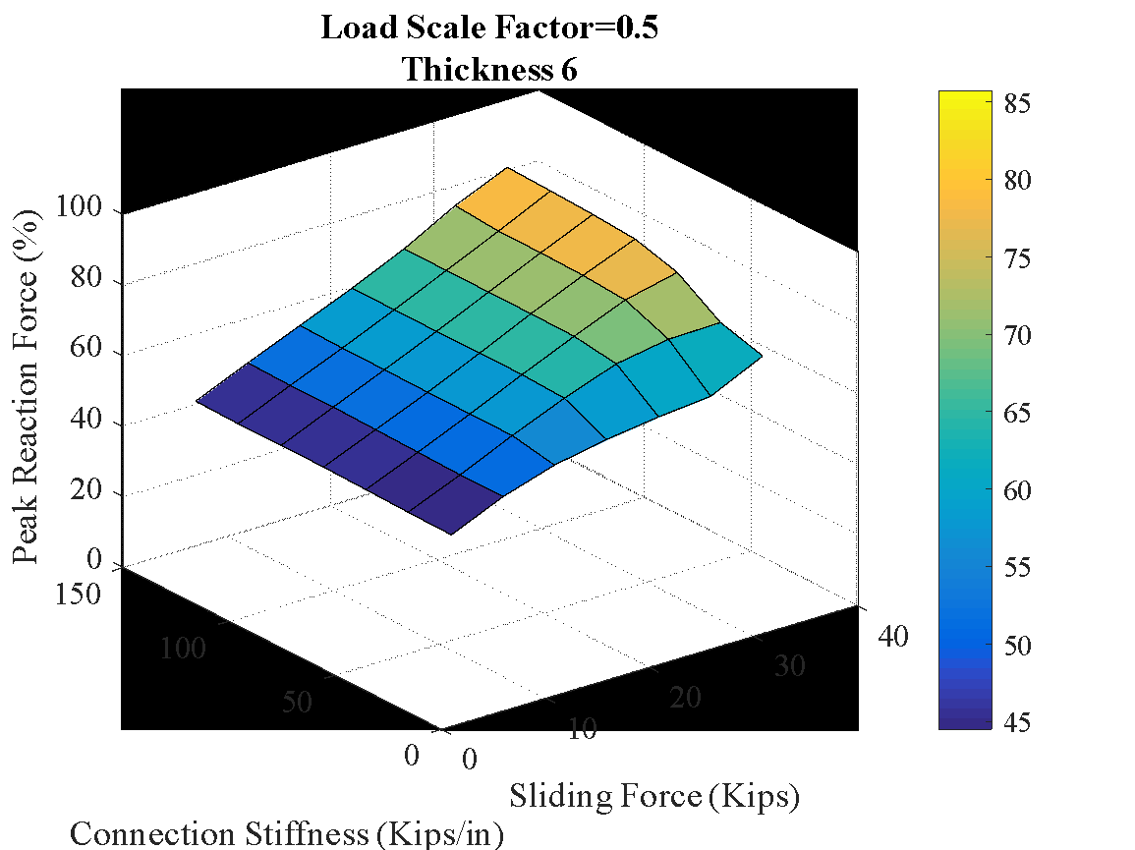
Figure 2
Force Transmissibility: The peak ratios for the reaction of the connection known to be flexible and the reaction of the pin support usedp
In figure 2 above, the flexible connection’s stiffness and sliding force is shown. The flexible connection in figure 2 is assumed to have an infinite deformation capacity. The stiffness and sliding force in the figure may assist in calculating a low force transmissibility, but this calculation must remain realistic to be adapted in the testing phase and contribute to results.
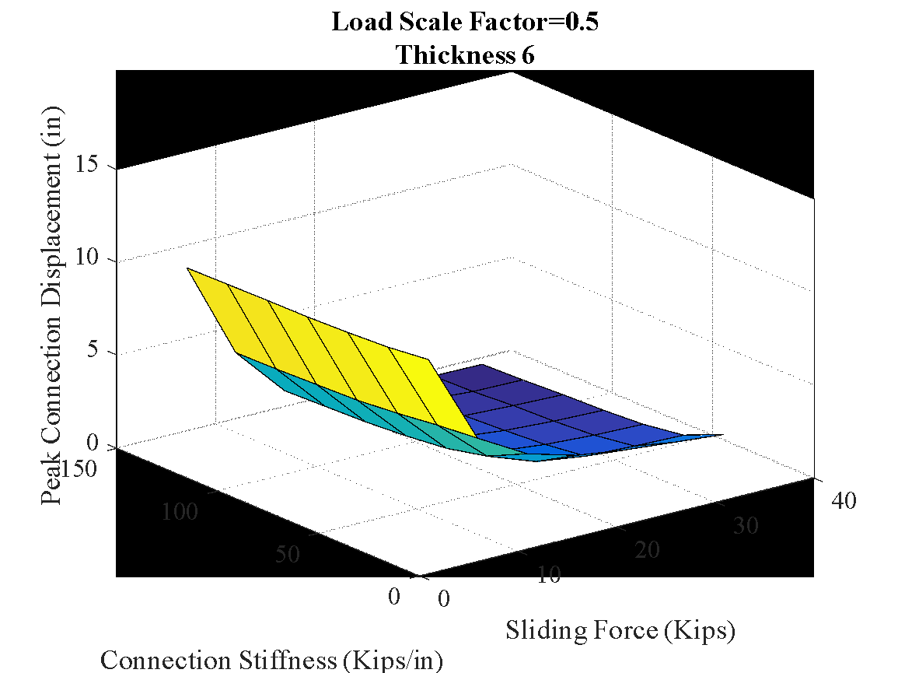
Figure 3 Connection Displacement
Figure 3 displays the amount of movement that figure 2 can experience from having infinite deformation capacity. It is important to acknowledge that both figures 2 and 3 replicate only 50% of the intensity that the actual blast load will administer. Notice that as the sliding force increases the amount of displacement decreases. These calculations have to remain feasible to apply to future testing
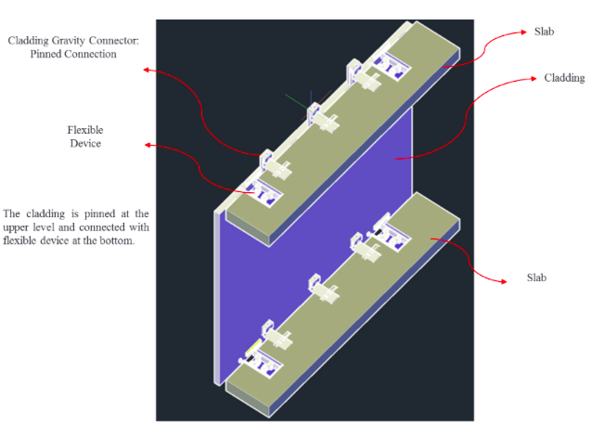
Figure 4 Flexible cladding connection at both top and bottom
Figure 4 displays the idea of our research and a flexible being used. Our results have proven our research to be legitimate thus far. A test will be conducted in the forthcoming months that will test any remaining skepticism. Future testing is vital because as of now, our data is based on a numerical approach which has the possibility of containing miscalculations or slight error. During future testing the precast concrete cladding design may be used on an actual shock test tube. This will allow us to replicate the effects that an actual blast load would have on a smaller scale. The difference between the cladding designed on SBEDS and the one we’ve used to test our research is the amount of flexibility. Opposite to the flexible one used for our research, the one created on SBEDS will have a rigid connection between the cladding and the floor diaphragm. By comparing the damage resulting from a rigid connection and a flexible one, we demonstrate the significance of our research where the flexible results in less damage. Also, the results from actually applying the cladding panel in testing with a flexible connection will disclose if SBEDS was capable of correctly predicting the damage. If not, we can compare how inaccurate the calculations attained from SBEDS were or how close to the testing data. The flexible connection should ultimately have a reduced force transmissibility. Referring back to figure 2, the stiffness and sliding force displayed can assist in the testing phase to calculate a low force transmissibility. The future testing will answer questions that engineers may be skeptical about when applying our research to practice and will provide data beyond calculated numbers, making the research more reliable. It will provide engineers with actual testing data and calculations. We anticipate that future testing will validate the accuracy of the analytical model created in Open Sees by Safwan Al-Subaihawi. This model can be used by engineers in practice if testing shows that it captures the response of displacement, support reaction, and the cladding damage at an exceptional rate. Our results will be fully validated after all the testing is complete and should corroborate that flexible connections mitigate blast load hazards.
Summary and Conclusion
We anticipate that our study and results will contribute to the progress of safer buildings and less economical stress during unexpected natural hazards, specifically blast loads. However, to be accepted our results still have to be completely confirmed by future testing. Unlike past methodology, this methodology emphasizes the design process of the entire structure specific to unperceived threats. The design of the structure is based on improving the most vulnerable parts that make it more likely to collapse. By installing flexible cladding in between the connection system and floor diaphragms, mitigation to a degree has been analytically achieved. Scheduled future testing will corroborate our overall results and prove mitigation was achieved.

Acknowledgements
Thank you to Karina Vielma-Cumpian for the guiadance and my mentor Dr.Quiel, who provided knowledge, patience, and guidance throughout my research experience. Also, to graduate student Safwan working on the same research who explained and shared with me the higher level components of the research that he conducted. All the people at ATLSS who allowed us to contribute to their summer research projects and REU/NHERI for funding an educational experience.
References
- Cimellaro, G.P., Reinhorn, A. M., and Bruneau, M. (2010). “Framework for analytical
quantification of Disaster resilience.” Eng. Struct., 32(11), 3639-3649
- Quiel, S. E., Marjanishvili, S. M., and Katz, B.P. (2015). “Performace-Based
Framework for Quantifying Structural Resilience to Blast-Induced Damage.” Journal of Structural Engineering, 142(8.).

