A Field Study of Wind-Driven-Rain Intrusion and Subsequent Interior Damages to a Full-Scale Model House

Caleb Wegener
Humboldt State University

Dr. Ioannis Zisis, Farzaneh Raji

NHERI Wall of Wind Experimental Facility
Florida International University
Miami, Florida

(ASCE)
Abstract
The impact of wind-driven-rain (WDR) intrusion and subsequent damages to the interior of low-rise residential buildings from tropical cyclone (TC) storms has not been adequately studied. Public loss models currently rely on empirical methods to estimate the impact of WDR intrusion in houses. There is an immediate need to perform experimental research in this area and understand the level of interior damage which can be expected during extreme wind and rain events. The objective of the current study was to generate experimental based evidence for improvements of public loss models, building codes and insurance estimations while helping safeguard coastal communities against TC storm systems. The study was carried out at the Natural Hazards Engineering Research Infrastructure (NHERI) Wall of Wind (WOW) Experimental Facility (EF) at Florida International University (FIU). This paper presents the protocols used to design and field-test a full-scale model house to determine the damage incurred by storm systems. Two damage scenarios are examined through the research and the up to date findings are presented.

Introduction
Coastal areas are particularly prone to experience extreme wind and rain events such as hurricanes. These hurricanes, formally called tropical cyclones (TC), are common through all parts of the Caribbean and are formed over tropical or sub-tropical waters (NOAA). These storms usually start off heading west over the Caribbean but then head north and can shift, move, or change direction rapidly. A TC becomes a hurricane when it produces maximum sustained winds over 74mph. On average, 6.2 hurricanes are formed in the Atlantic each season which begins June 1st and ends on November 30th each year. Unfortunately, many of these storms make landfall bringing significant damage with them. This damage comes in many forms and results in loss of life and significant financial devastation. The destruction they bring with them is unpredictable and sudden with only 36-48 hours to respond to TC advisories. From 2005 to 2007 hurricane losses in the United States alone are estimated at 168 billion dollars with an average of 35.8 billion lost to TC storms per year (National Science Board 2007).
Insurance companies struggle to estimate potential damages to residential and commercial structures due to hurricanes. Many structures receive much more severe damages from hurricane induced flooding and winds than predicted in storm simulation and modeling (FEMA 2005). The inability for accurate assessment of risks from these storms may result in significant losses for insurance companies and potentially the lack of monetary funds to cover insured properties. The risk potential is based on geographic location and is supposed to account for storm surges and flooding. Post-storm surveys emphasize the need for more complex modeling of TC storms and their affected areas.
In post-hurricane studies, damage has been observed which deviates from the Florida public hurricane loss model (FPHLM) (FEMA 2005). The FPHLM is the only fully documented and accepted loss model available to make predictions and estimations of losses due to future TC events. It is considered the most reliable model of its type; however unexpected damages continue to occur. Interior damages due to WDR intrusion into the building envelope is observed even for areas with lower wind velocities than predicted by the model. This underperformance of the FPHLM highlights the need for a more scientific approach to model WDR intrusion in high wind conditions and for lower wind conditions which affect an even greater percentage of the global population (Baheru 2014).
Most of the damage done to buildings which are constructed according to current building codes is from WDR intrusion. WDR enters a structure when there is a failure or defect in the building envelope (Baheru 2014). WDR can also enter when the wind causes a breach in the building envelope either through direct pressure or when wind-borne debris strikes the home. It is important to know how much water accumulates in each area of an affected building for integrating this research into the FPHLM. A better understanding of WDR with simultaneous turbulent wind loading data will help to model this behavior into the FPHLM and other hurricane damage simulations.
Current WDR flow models are based on field data and WDR intrusion into the building interior is based on empirical models not real world data (Baheru 2014). Since interior and content damage is a function of WDR and external building damage (Vickery 2006), there is a demand for the ability to model WDR intrusion accurately. The problem of WDR has been approached from a physics and probability approach which tries to account for all the components of a building, but lack experiments on the building envelope to verify the claims (Pinelli 2011).
Decision makers, insurance, industry, and homeowners all stand to gain from a better modeling of WDR in the FPHLM. The main question is how to mitigate future losses from WDR during TC storms. The damages from WDR are avoidable and exist because of a disconnect between industry, building codes, technology and the scientific research that is made possible at the WOW.
The Florida International University NHERI Wall of Wind (WOW) Experimental Facility (EF) has been designed and built to simulate hurricane level winds and wind-driven rain (WDR) intrusion. With growing demand for full-scale-model testing the facility is designed to produce sustained winds of up to 157 mph across a rotatable testing table. The facility can accurately replicate WDR scenarios by using pressurizes spray nozzles located down-wind of the fans (Chowdhury 2017).
Simulations of WDR while varying external damage conditions of the building envelope along with different RSD parameters, wind speed and direction, have been conducted at WOW previously (Baheru 2015). Water intrusion was quantified as well as the distribution of WDR in the interior portions of a model house. To better understand how damages to interior and contents can be modeled based on WDR intrusion into the building envelope, previous work will be combined with turbulent wind loading data to determine in which areas of a structure the water can be expected to accumulate. This research will itemize common building contents and interior components (walls, flooring, electrical components) to determine which level of damage that component can withstand before the damage warrants full replacement of that component.
The previous work of Baheru and the current research being done at the WOW facility will be synthesized into an improved test-based model for WDR intrusion for the FPHLM. New WDR testing protocols will be developed and tested during experiments in the WOW. Combining that knowledge with observations of the model house before and after field testing, a better understanding of WDR and its subsequent interior damages will be presented.
Methods
To further understand WDR and how it damages the interior of a building, field studies will be conducted on a full-scale model house. Findings from this study can be coupled with previously acquired and future data on WDR intrusion into the building envelope during TC events and can be integrated into the FPHLM to better estimate losses from the destructive storms. The details of the model house, instruments used to describe weather events, as well as the sources for external weather data and tools to determine rain penetration into the model house are discussed further in this section.
Supplies used are listed below:
-Ultralight 1/2” Gypsum Board
-Plus 3 Lightweight All-Purpose Pre-Mixed Joint Compound
-Drywall Joint Tape 2-1/16”
-Drywall Screws 1-5/8” #6
-Inside Corner Tool 4 x 3-1/2”
-Hammer-End Joint Knife w/Comfort Grip Handle
-White Flat Interior PVA Primer
-Ultra Pure White Flat Zero-VOC Interior Paint
-Metal Roller Tray
-Heavy-Duty Roller Frame
-High-Density Woven Roller Cover 9 x 3”
-Tuff-Lock Pole Sander 3-1/4” x 9-1/4”
-Drywall Sanding Screens 4-3/16 x 11-1/4” 120 Grit
-Plastic Tubing 1/2”
-Blue Plastic Storage Box
-ProTRAK 3-5/8” x 10ft. 25-Gauge EQ Galvanized Steel Track
-Delmhorst Moisture Meter BD-2100W/CS Bd-2100 w/drywall probes

WDR intrusion through an opening is given by Equation 1 (Baheru 2014) where $V_{tot}$ is the total volume of water allowed through an opening and $V_{DI}$is the volume of direct impinging rain;
$V_{total}= V_{DI}+V_{SR}$ (Equation 1)
$V_{SR}=$ volume of surface runoff rain. Direct impinging rain is the rain that is free falling and enters an opening in the building without first striking another object; surface runoff is the water that strikes the building envelope and enters a breach in the building envelope with the aid of pressure differentials around the building and/or through gravitational and fluid properties.
In previous studies, the focus was on WDR intrusion into the building envelope. Electronic tipping bucket rain gauges, Hydrological Solutions Model TB3, were used with water being funneled into the gauge from openings in the building envelope. In this research, these rain gauges will also be used to measure the amount of rainfall near to the model structure and to measure WDR using a custom built WDR gauge. Basing the design for the WDR gauge on work by Nore, it was deemed useful to look at how much rain is falling horizontally and how much 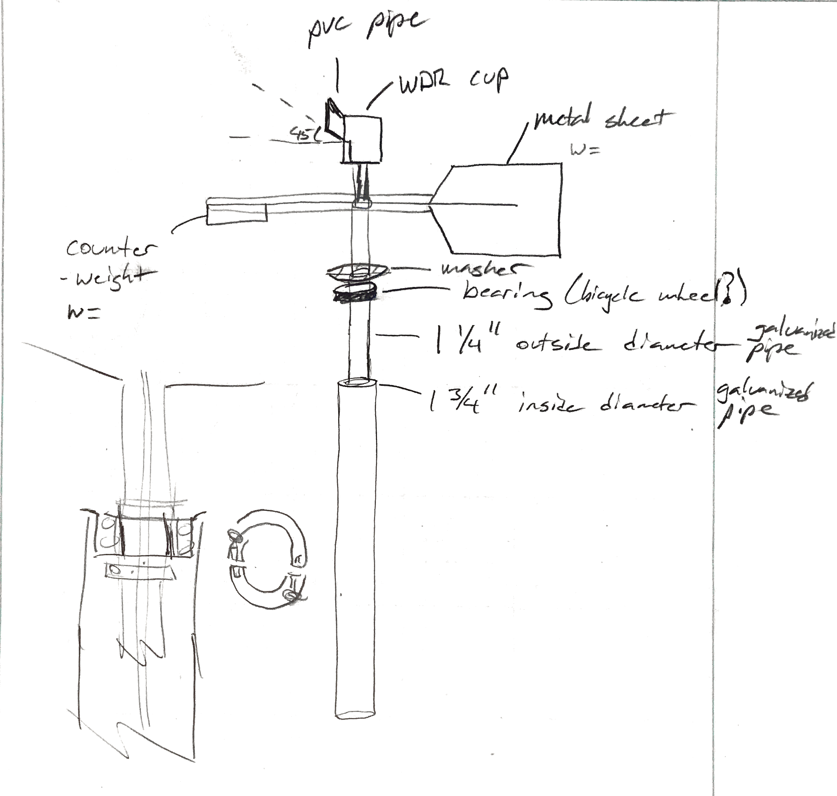
Figure 1 - WDR Gauge Prototype
rain is falling vertically. The design is like that of a weather vane with a rain cup attached at the top and tubing running down through the frame to a rain bucket below as shown in Figure 1. No matter which direction the wind is blowing the rain cup will always face into the wind. The instrument is tested inside the WOW to determine if the rain cup is facing the correct direction during wind storms and to determine its durability during high wind events. The rain cup is the same custom rain cup used in previous work by Baheru.
Using custom designed rain cups has been a helpful way to quantify the amount of water at different positions around the structure during hurricane WDR simulation in past research. These rain cups have a removable lip; when removed, it allows surface runoff water to be collected and measured using the cups. When the lip is on, the cups will not allow surface runoff water collected on the façade of the building to enter the cup. This design allows for the distinction between direct impinging rain droplets and surface runoff water when taking measurements. These rain cups have drainage tubes to be connected to a rain gauge. These rain cups are implemented in this study to measure the WDR both at the angle of the building and in the direction of incoming wind. The volumes of WDR can be compared that to free-falling rain volumes.
A thermal imaging camera has been used to determine the distribution and concentrations of moisture present into the building components during periods of rain in past work. This method is often used to determine moisture absorbance and distribution on the facade of buildings (Lerma 2011). It has been found through practice that the thermal imaging camera is also helpful to locate areas with minimal moisture that are difficult to locate with the naked eye. The camera used at the WOW is a FLIR model B400 with temperature sensitivity of 0.05°C at 25°C. Thermal images will also be utilized in this research to verify damages to gypsum-board walls along with a moisture meter Delmhorst Moisture Meter BD-2100W/CS Bd-2100 w/drywall probes to relate WDR intrusion to interior damages.
This research focuses on the effects of interior water damage from WDR to the overall building damage. A full-scale model house which was used in previous work at the WOW is used to complete the field study. The house measures 100”x112”x109”(l*w*h) and roof measuring 124”x132”x______with a 3/12 pitch and wood construction. Gables are constructed with treated 2x8” lumber and 3” metal flashing. The house has a shingle roof with vinyl siding. Two windows and a door. Field studies will be conducted on this model house during storms which have below hurricane level winds and short duration to estimate the damages and rainfall amounts accurately.
The weather is monitored closely to identify short durations storms with higher than normal wind gusts. When an appropriate storm is identified, a team is on-call to take weather data which will be related to rain and wind data gathered at the WOW as well as weather data available online through NOAA. The team also records observations on the model house both before and after the storm to identify WDR intrusion and subsequent damages.
Weather data provided by NOAA at the Miami International Airport roughly 6 miles from the WOW and onsite weather data collection module Davis Vantage Pro 2 along with WDR volumes collected with the various rain gauges installed at the WOW will help link these storms and their properties to the interior damages on the model house. The weather station is selected and purchased for this research based on the fact it is an all-in-one system with wind speed and direction, rain, and temperature readings. The chosen instrument needs to provide wireless downloading to an integrated data logging module for real time data collection along with small solar panel to power the data transfer. The data is downloaded from the provided data logger into Excel via PC link cable.
WDR intrusion and subsequent damages to the interior components of the house will be carefully observed and recorded. The interior wall will have ½” gypsum-board installed, screw holes and seams sealed with drywall mud and tape, after which the walls are primed and painted. Buckets will be installed covering the floor of the model house to see how much water accumulated at different areas of the house from the open window which is facing ____ as determined to be the direction which the wind is most likely to strike at the WOW. Along the walls a gutter system is installed to determine how much WDR strikes the wall and collects into these gutters which drain into buckets which are sealed so that only the water coming off the interior walls is collected. The field studies will start with the least destructive testing first and progress with small window openings and finally simulating a missing window.
Once damages are inflicted on the model house, interviews and surveys will be conducted with currently licensed Florida contractors and inspectors to determine costs of replacement or repair whichever is most appropriate for each damage scenario. Repair times and subsequent costs for the displacement of a family from their homes will also be examined in this research.
Results
To understand how the gypsum board would be damaged during a TC event, a small 2x2ft piece of gypsum board is primed and painted then mounted vertically to test for water penetration when applied with a spray bottle. Moisture readings are taken at the beginning of the test and between 2 minute intervals of spraying. The spraying is concentrated on one area of the board and 3 separate 2-minute spray intervals are performed. It is determined that a finished wall as simulated in this test will not absorb water from short contact with raindrops on the side which has primer and paint applied as would an interior wall of a house. Based on these findings we expect to get little damage to the walls because the water will not accumulate on the surface due to gravity. If water accumulates on the floor or runs down the inside of the wall and contact the unfinished side of the wall, the drywall is at risk for water absorption.
Case 1 simulates minimal exterior damage; the window is left open 1” to allow a small amount of WDR to enter. In case 2, the window is left completely open simulating a moderate damage scenario where the window is broken.
Discussion
The fact that field-testing of this nature requires a storm to come which begins and ends on the same working day means that some time is required to obtain the necessary data. These storms are not unlikely at the WOW but to have all the instrumentation set up and the team assembled for data collection adds another component which is vital. Because weather patterns show that most of the high winds are from the east, does not mean that every storm will approach from that direction and it may not be possible to predict and reposition the house based on the storms direction so the storm need to also be approaching the open window or else the data is not able to be acquired.
As with any field-testing, this study has some possible errors in the data collection and storm characterization. The weather station on-site is not expected to be 100% accurate. The Miami International Airport weather station is not close enough to be able to guarantee that the data is exact. The custom rain cups and the WDR have the potential to have water droplets left in the container or tubing leading to the tipping bucket rain gauges and therefore not all the rain water will be quantified. The arrangement of the plastic containers in the model house have small gaps where water would not be captured; however, this can be estimated using the inferred imaging camera in the post storm survey. The model house was not fitted with wood trim windowsills and therefore the lumber used in construction and the edge of the drywall are painted and primed which is likely to offer less protection against WDR landing on the windowsill and then being absorbed by the drywall than if the windowsill was trimmed as is traditional in new home construction.
The results will be fitted to the FPHLM through specific criterion. Interviews will be conducted with Florida-local contractors to determine what the average repair time and associated costs of repairs would be on a home experiencing the level of WDR intrusion and subsequent damage observed in the study. However, the repair times in a post-storm scenario are likely to be significantly longer than during a normal periods and therefor the contractor cannot properly estimate this repair time or the damages that would occur after the storm from moisture and mold growth in the home after a storm because there are too many factors and possible storm cycles to consider.

Works Cited

Baheru, T., Chowdhury, A. G., (2014). “Simulation of wind-driven rain associated with
tropical storms and hurricanes using the 12-fan Wall of Wind.” Building and Environment. V. 76. P. 18-29.
Baheru, T., Chowdhury, A. G., Pinelli, J. P., (2015). “Estimation of Wind-Driven Rain Intrusion
Through Building Envelope Defects and Breaches during Tropical Cyclones.” Nat. Hazards Rev. V. 16(2).
Chowdury, A. G., Zisis, I., Irwin, P., Bitsuamlak, G., Pinelli, J. P., Hajra, B., Maravej, M.,
(2017). “Large-Scale Experimentation Using the 12-Fan Wall of Wind to Assess and Mitigate Hurricane Wind and Rain Impacts on Buildings and Infrastructure Systems.” Journal of Structural Engineering.
FEMA, “Summary Report on Building Performance, 2004 Hurricane Season,” FEMA 490,
2005.
Lerma, J. L., Cabrelles, M., Portalés, C., (2011). “Multitemporal Thermal Analysis to Detect
Moisture on a Building Facade.” Construction and Building Materials 25, 2190-2197.
National Science Board. (2007). Hurricane Warning: The Critical Need for a National Hurricane
Research Initiative.
NOAA. “Tropical Cyclone Climatology.” <http://www.nhc.noaa.gov/climo/> (Jul. 29, 2017).
Nore, K., Blocken, B., Jelle, B. P., Thue, J. V., Carmeliet, J., (2007). A Dataset of Wind-Driven Rain
Measurements on a Low-Rise Test Building in Norway.” Building and Environment 42, 2150-2165.
Pinelli, J. P., Pita, G., Gurley, K., Torkian, B. Hamid, S., Subramanian, C., “Damage
Characterization: Application to Florida Public Hurricane Loss Model.” Natural Hazards Review. 2011. V. 12(4). P. 190-195.
Vickery, P. J., Skerlj, P. F., Lin, J., Twisdale, L. A. J., Young, M. A., Lavelle, F. M. HAZUS-MH
Hurricane Model Methodology. II: Damage and Loss Estimation. Natural Hazards Review. May. 2006. P. 94-103.

