Experimental Observations of Debris Impact and Damming Loads for Elevated Structures Subjected to Transient Waves

Anna C.T. Tsai
University of Washington
Natural Hazards Engineering Research Infrastructure Research Experience for Undergraduates
Oregon State University Summer Undergraduate Research Fellowship
Faculty Mentor: Dr. Daniel Cox

- Abstract
Tsunami events have major impact on coastal communities including loss of life, and high economic damage. Tsunami in the past decade such as the 2011 Tohoku, Japan tsunami have led to greater interest in and awareness of the risks posed by tsunami to coastal communities. Tsunami can damage critical structures in a variety of different ways, including from the impact of waterborne debris on buildings. A model, $F=v_{i}\sqrt{km}$, has been proposed and validated for the impact force of a single debris impacts on structures. However, it is less known what the forces will be in the case of multiple debris impacts on a structure. To validate the currently accepted model for peak impact force for the case of multiple debris impacts, it is necessary to establish a value for the stiffness of the system being studied. This paper details a proposed methodology for estimating impact velocity and calculating system stiffness based on video data taken as part of a larger study on tsunami loads on structures. This method uses optical tracking in using MATLAB to estimate impact velocity which can be used to calculate system stiffness. The resulting value can be used in calculations of peak impact force for waterborne debris impacts in the case of multiple debris impacting a structure.

- Introduction

Recent tsunami events such as the 2011 Tohoku, Japan, tsunami have shown that tsunami have tremendous negative impacts on coastal communities. Tsunami cause devastating levels of damage to communities, infrastructure, and lead to huge losses of human life (Goseberg et. al., 2016). The losses from tsunami are significant, but like other natural disasters, preparedness can help reduce the damage. However, tsunami occur less frequently than earthquakes and hurricanes (Naito et. al., 2013), so there is currently a lack of understanding about how to prepare for such an event. Because the risks are less well studied, there are many uncertainties on how to design structures such as evacuation shelters to withstand a tsunami event (Goseberg et. al., 2016). Better understanding of the risks posed to infrastructure in a tsunami event can lead to the development of better design practice, which may save lives and reduce economic impacts.
In a tsunami event buildings and other structures are at risk from both the forces developed by the fluid of the tsunami wave and the forces of waterborne debris impacts (Chock, 2015). These debris impacts can be significant in coastal communities near ports where there are many large movable objects such as fuel storage containers and shipping containers (Riggs, et. al., 2014). After the Tohoku, Japan tsunami, it was observed that fuel storage containers moved because of the tsunami, sometimes as far as one kilometer (Naito et. al, 2013). The movement of such objects towards onshore structures can have devastating consequences if they collide with structures and impart a large impact force for which the structure may not be designed for. These collisions may increase the forces experienced by structures such as emergency shelters and evacuation routes during tsunami events, but their exact result is largely unknown. Studies into this topic have investigated the impacts of debris in floods (Haehnel et. al., 2004), or single pieces of debris in tsunami events (Riggs et. al., 2013). However, few studies have considered the likely case of multiple debris impacts.
The current American Society of Civil Engineers (ASCE) 7 Design Standards use a model for peak impact force based on a single debris impact validated by Piran Aghl et. al., 2014. This expression estimates peak impact force as:
$F=v_{i}\sqrt{km}$ (1)
where F is impact force, v_{i} is impact velocity, m is structural mass, and k is effective stiffness of the debris. In this model, the debris is modeled as an equivalent one-dimensional bar with effective stiffness:
$k=\frac{EA}{L}$ (2)
where E is modulus of elasticity, A is cross-sectional area of impact, and L is the length of the impacting debris. It can be difficult to obtain a value of k analytically, so instead stiffness can be estimated from the slope of the line of peak impact force versus impact velocity (Ko et. al., 2015). Having an accurate estimate of system stiffness is important for calculating expected peak impact velocity using the model from ASCE 7.
This expression has yet to be validated for multiple debris impacts. The purpose of this paper is to develop a methodology for estimating system stiffness (k) from a tsunami experiment conducted in the Oregon State University O.H. Hinsdale Wave Laboratory’s Large Wave Flume. large wave flume using multiple debris with several debris orientation and evaluate the validity of the model presented in Eq. (2) in the case of multiple debris impacts.

- Literature Review

Current research on tsunami debris impacts predominately focuses on three areas: field studies of tsunami impact zones, experimental studies on single debris impacts, and studies on multiple debris motion and tracking. While these studies present an understanding of the risks of tsunami debris impacts, there is little research addressing the impact forces of multiple debris (Goseberg et. al., 2016), though this is a likely given that tsunami usually occur in areas with many moving objects such as shipping containers and fuel containers.
Field studies of tsunami impact zones have shown that debris impacts cause significant damage. A post-event field study of the 2011 Tohoku, Japan, tsunami showed multiple instances of fuel storage containers failing and impacting buildings (Naito et. al., 2013). In some cases, the failures were possibly due to debris impacts, and in others, the failures were a result of hydrostatic forces. In the cases where the containers impacted buildings, significant damage occurred. These containers acted as movable objects, and in some cases moved up to one kilometer from their original locations (Naito et. al., 2013). Other field studies conducted after the Tohoku tsunami show a range of examples of structural failure resulting from debris impacts (Naito, et. al., 2014). The damage resulting from tsunami debris impacts is evidence that designing for such impacts is important for tsunami resilience.
One of the methods for designing for debris impacts is to quantify the risk posed by debris movement by classifying debris by mass, stiffness, size, and buoyancy (Naito et. al., 2014). This allows designers to better understand the risks that may be present in the case of a tsunami event. However, as field studies have shown, there is risk from multiple debris impacts, but it is currently unknown how forces develop in these circumstances (Goseberg et. al., 2016).
Studies on single debris impact have verified numerical models for these cases. Haehnel et. al., 2004 developed a single degree of freedom model considering the mass of the debris, the impact velocity, and the effective stiffness of the collision between the object and the structure. However, this model does not evaluate tsunami forces directly, rather for wooden debris such as logs in the case of floods. Later studies focus more directly on tsunami impacts, but only for the case of single debris impacts. Piran Aghl et. al., 2014 verify a similar model shown in Equation (1) for full-scale in-air impacts that models the debris as a uniform elastic bar. This model was also tested and verified for single debris impacts by Ko et. al., 2015 using small-scale tests. The results from both these studies is summarized in Riggs et. al., 2014, which concludes that the effect of the water on the peak impact force is less important than the effect of the debris on the structure.
One potential method for studying multiple debris impact is to use debris tracking methods such as optical tracking (Ruben et. al., 2015) or “smart debris” with embedded trackers (Goseberg et. al., 2016). Optical tracking methods have been shown to be effective for tracking the motion of up to nine pieces of debris. However, this method only examines the movement of debris and not the forces developed in an impact. The “smart debris” system uses boxes with Bluetooth trackers that can provide information on the motion of the boxes (Goseberg et. al, 2016). This system has been used to quantify the motion of debris in the presence of obstacles such as those that would be present in a port (Goseberg et. al., 2016). However, again, there was no study into the peak impact forces. In addition to not having direct applicability to impact force, both these methods require involved setups, particularly for the “smart debris”. For experimental work where tracking is not the primary goal a simpler methodology for tracking the debris may be desirable.
Another gap in the research is in the effects of debris damming. In the case of multiple debris impacts, it is plausible that the debris would pile up against a structure which may block any openings present in the structure that would otherwise allow water to flow through. This damming effect may increase the force on that structure. Work has been done to develop models for a debris damming scenario in the case of a flood (Martinez-Martinez et.al., 2017), but there are few studies that focus on debris damming loads in tsunami.
Given that the most likely real-world scenario is multiple debris impacting a structure, it is important to understand the forces developed in such a case. Research to date has shown that it is possible to track multiple pieces of debris, and to model a single piece of debris. Looking forward there is a need for more studies for developing methodologies to evaluate the forces developed in the case of multiple debris impacts, and under debris damming loads.

- Debris Impact Experiment

This experiment is part of a larger study known as the “Orange Box Experiments” examining the loads on a structure under various simulated tsunami conditions. Experiments for this study were conducted in the Oregon State University O.H. Hinsdale Wave Research Laboratory Large Wave Flume (LWF). The LWF is equipped with a piston-type wave maker that allows for the simulation of scaled tsunami-type waves. The data examined in this paper was collected as part of the third phase of the Orange Box Experiments, which investigates multiple debris impacts and damming effects on a structure in a tsunami.

Experimental Setup
The experimental specimen was an orange box with twelve columns that represented an elevated coastal structure on 1:10 scale. This box was placed in the wave flume as seen in Figure 1. The box was instrumented with two horizontal load cells, four vertical load cells and two transverse load cells to measure the force of impact at significant points on the box.

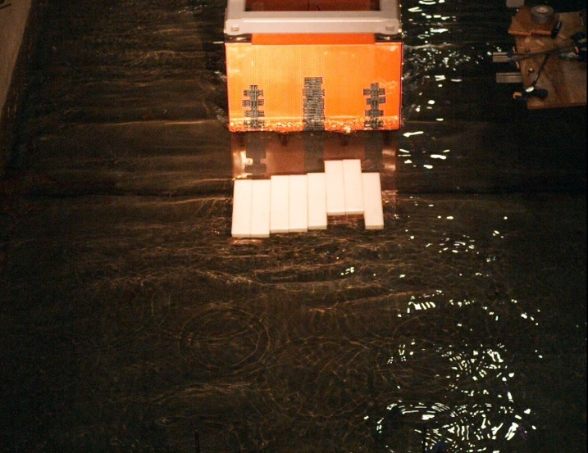
Figure 1: Orange box in LWF during Debris Impact Testing

In-water tests were conducted with debris represented by high density polyurethane (HDPE) blocks weighting 2.55 g. A total of fifty-nine trials with twenty-three different debris layouts were conducted. The layouts varied both debris orientations and number of debris. These different layouts are summarized in Figure 2

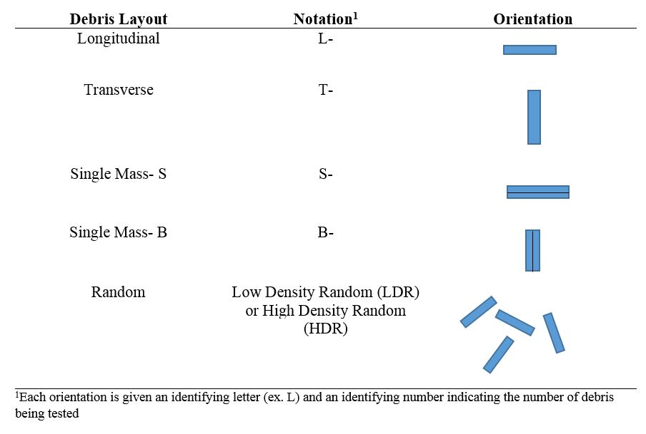
Figure 2: Summary of debris layouts and orientations for in-water tests

In addition to the in-water tests, in-air tests were conducted. For these tests, the orange box was placed in the wave flume and impacted with a HDPE block suspended like a pendulum (see Figure 3).

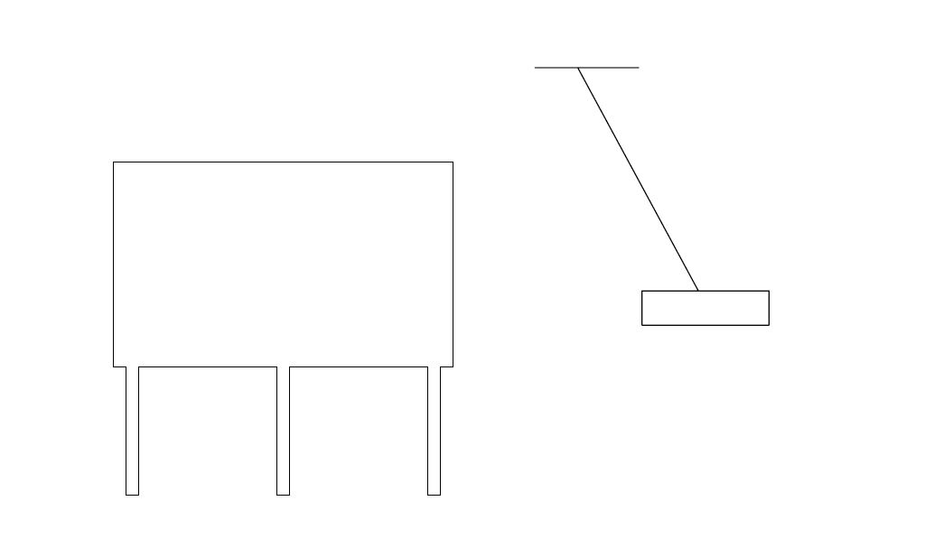
Figure 3: Swing Test Setup (figure not to scale)

In some cases, more than one block was used, however only the trials with a single HDPE block were analyzed. At the bottom of the box a ruler was placed as a reference to obtain position data. The swing test layout can be seen in Figure 4. For each trial, the block was pulled back either 60-cm or 30-cm and allowed to swing freely and hit the orange box.

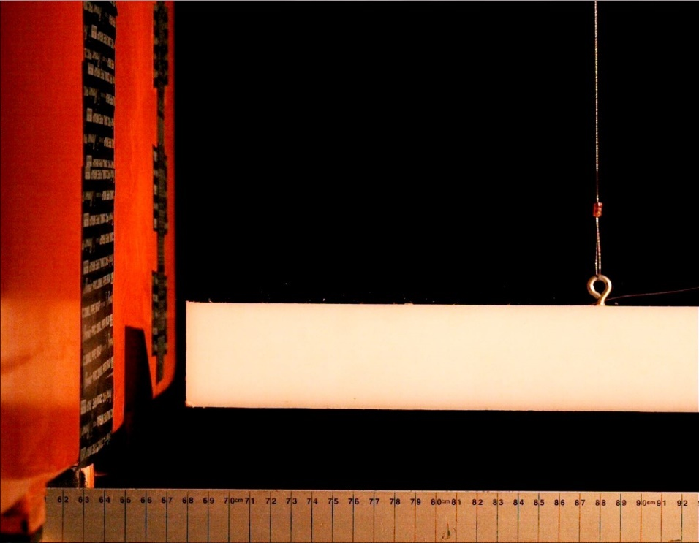
Figure 4: In-air swing test

Methodology for Velocity Tracking
Both the in-air and in-water tests were recorded on video. These videos were then analyzed using MATLAB to obtain impact velocity estimates. The in-air tests are used for estimating system stiffness (k) while the in-water tests can be used for validating the peak impact force model for multiple debris impacts. To-date only the in-air tests have been analyzed.
Rectification for video perspective distortion similar to Ko et. al., 2015 was considered but not applied. The video data was not gathered with the goal of optical tracking in mind, so it was difficult to obtain reference points for accurate image rectification. In addition, the pixel-to-known distance ratio as measured using the ruler visible in the frame was approximately constant across a single frame, so it was assumed that the perspective would not need correction.
For each swing test analysis was performed on a video clip starting at approximately 2 seconds before the debris impacted the structure and ending approximately 2 seconds after the impact. This duration was chosen to capture the motion of the debris directly before and after the impact without having a clip long enough to make processing times impractical.
Debris position was estimated by finding and tracking the interface of the block with the background based on the intensity of the whiteness of the block. For each frame, the image was first converted to grayscale, made into a binary image, small pixel groups representing bright spots that were not the block were filtered out, and then the interface between black and white was located. The steps for interface tracking are shown in Figure 5
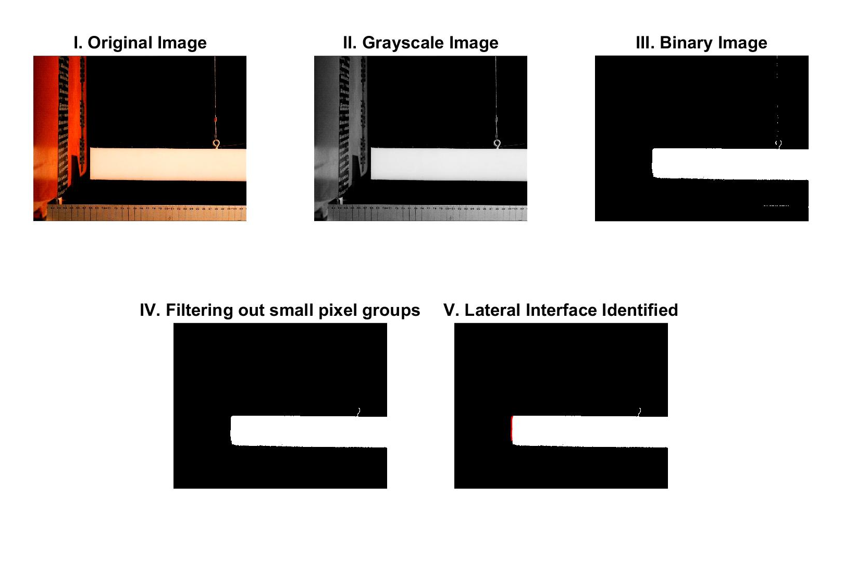
Figure 5: Optical Tracking Method Steps
Once the position of the block was obtained the results were smoothed using the built-in smoothing function in MATLAB. From the smoothed position data, velocity was calculated using a 5-point centered difference stencil with the following equation:

$$v(t)=\frac{x\left(t+2dt\right)+8x\left(t+dt\right)-8x\left(t-dt\right)+x(t-2dt)}{12dt}$$

Where x is the position of the lateral interface of the block (m), t is time (s), and dt is the time interval, or the inverse of frame rate (seconds per frame).
The alternative method of calculating velocity is to use the basic definition of velocity as expressed by the following equation:
$$v\left(t\right)=\frac{x\left(t+dt\right)-x(t)}{dt}$$
However, the centered difference method was chosen because calculating the velocity using the definition of velocity resulted in a very noisy graph, and the centered difference stencil performed better.
The velocity data was fitted with a Heaviside step function with a discontinuity at time when the block hit the orange box. The debris impact velocity was calculated using this function at 0.5 s before the impact.

- Results

Impact Velocities

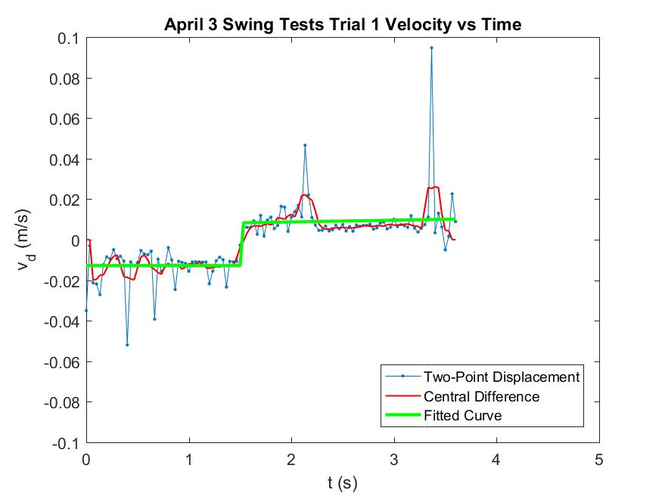
Figure 6: Velocity (m/s) versus Time (s) for Trial 1 with a 60-cm pullback distance

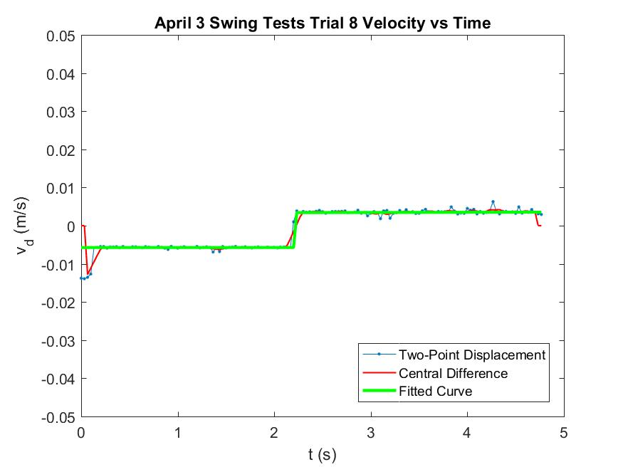
Plot of estimated velocity (m/s) versus time (s) for in-air swing test with a pull-back distance of 30 cm from box
Figure 7: Velocity (m/s) versus Time (s) for Trial 8 with a 30-cm pullback distance

For the 30-cm pullback distance the average estimated impact velocity was 0.0056 m/s with a standard deviation of 0.0001 (2.26% of the mean). For the 60-cm pullback distance the average impact velocity was 0.0122 m/s with a standard deviation of 0.00085 (7.23% of the mean)

Peak Impact Force
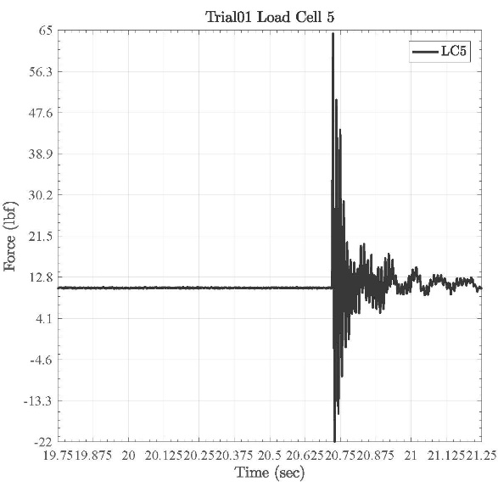
Figure 8: Force versus Time for Trial 1 with a 60-cm pullback distance

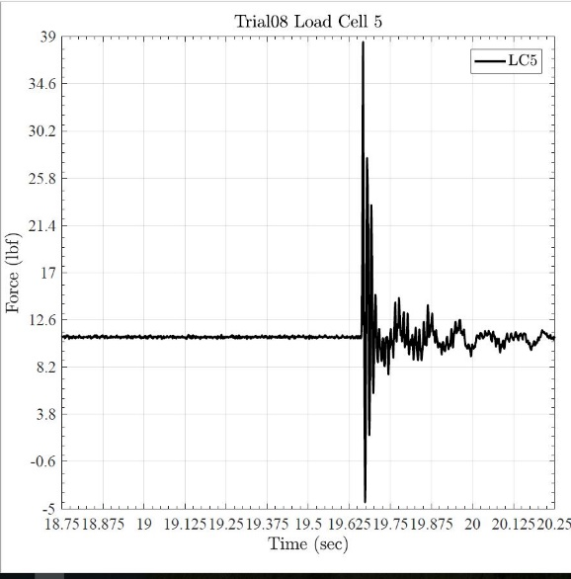
Figure 9: Force versus Time for Trial 8 with a 30-cm pullback distance

For the 30-cm pullback distance the average peak impact force was 173.88 N with a standard deviation of 2.56 N (1.49% of the mean). For the 60-cm pullback distance the average peak impact force was 294.76 N with a standard deviation of 7.24 N (2.45% of the mean).

System Stiffness

Estimated system stiffness is $1.21*{10}^{8}$ (N/m)

- Discussion

For each pullback distance, the estimated peak velocity is expected to be the same for each trial. Additionally, the measured impact force is expected to be the same for each trial. The data agrees with this because the standard deviations are less than 10% of the mean for both estimated velocity and measured impact force. However, the variability is lower for the 30-cm pullback distance than the 60-cm pullback distance. This could be because the velocity plots were smoother for the 30-cm pullback trials, meaning the trials were more precise.
Sources of error could be in the interface tracking procedure because it relies on filtering the block from the background based on the intensity of the whiteness, and this was not always consistent for each frame of the videos.
The measured forces are non-zero before the impact, which is not expected. This result could be affecting the measurement of peak impact force
The effective system stiffness is calculated from the slope of the line relating force to impact velocity. Theoretically this line should intercept the x-axis and y-axis at (0,0). However, doing that for this case made the line fit much worse. As a result, the calculated system stiffness is likely not highly reliable. This could be partially because the line is effectively compromised of two points because the forces and velocities for each pullback distance should be the same. Future work to estimate k could benefit from a greater number of trials to calculate the slope of the line.
Once k is known impact forces for in-water tests can be estimated using $F=v_{i}\sqrt{km}$ and then compared to forces directly measured through instrumentation. However, to validate this model for multiple debris impacts the velocity of the debris for the in-water tests will need to be calculated. One way to do this could be via use of optical object tracking similar to what was done with the in-air tests.

- Conclusions
Optical object tracking combined with direct measurement of impact forces can provide a way to estimate system stiffness for an experimental structural system. Once this parameter is known it can be used in the $F=v_{i}\sqrt{km}$ model for peak impact forces developed for single debris impacts to validate the model for multiple debris impacts. Opportunities for future work include improving the estimation of k with a greater number of trials, and using optical methods to estimate debris impact velocity for multiple in-water debris.

- Acknowledgements
Thanks to Dr. Daniel Cox and Mohammad Shafiqual Alam of Oregon State Unviersity for their help and support during this project. Thanks to the NHERI REU program for funding and support.

- References
Chock, G.Y.K., 2015 The ASCE 7 Tsunami Loads and Effects Design Standard. Structures Congress 2015. pp. 1446 -14 52

Goseberg, N., Nistor, I., Mikami, T., Shibayama, T. and Stolle, J., 2016. Nonintrusive spatiotemporal smart debris tracking in turbulent flows with application to debris-laden tsunami inundation. Journal of Hydraulic Engineering, 142(12), p.04016058.

Goseberg, N., Stolle, J., Nistor, I. and Shibayama, T., 2016. Experimental analysis of debris motion due the obstruction from fixed obstacles in tsunami-like flow conditions. Coastal Engineering, 118, pp.35-49.

Haehnel, R.B. and Daly, S.F., 2004. Maximum impact force of woody debris on floodplain structures. Journal of Hydraulic Engineering, 130(2), pp.112-120.

Ko, H.S., Cox, D.T., Riggs, H.R. and Naito, C.J., 2014. Hydraulic experiments on impact forces from tsunami-driven debris. Journal of Waterway, Port, Coastal, and Ocean Engineering, 141(3), p.04014043.

Martínez-Martínez, Luis Horacio, et al. "Woody debris trapping phenomena evaluation in bridge piers: A Bayesian perspective." Reliability Engineering & System Safety 161 (2017): 38-52.

Naito, C., Cercone, C., Riggs, H.R. and Cox, D., 2013. Procedure for site assessment of the potential for tsunami debris impact. Journal of Waterway, Port, Coastal, and Ocean Engineering, 140(2), pp.223-232.

Naito, C., Cox, D., Yu, Q.S.K. and Brooker, H., 2012. Fuel storage container performance during the 2011 Tohoku, Japan, tsunami. Journal of Performance of Constructed Facilities, 27(4), pp.373-380.

Piran Aghl, P., Naito, C.J. and Riggs, H.R., 2014. Full-scale experimental study of impact demands resulting from high mass, low velocity debris. Journal of Structural Engineering, 140(5), p.04014006.

Riggs, H.R., Cox, D.T., Naito, C.J., Kobayashi, M.H., Aghl, P.P., Ko, H.S. and Khowitar, E., 2013, June. Water-driven debris impact forces on structures: experimental and theoretical program. In ASME 2013 32nd International Conference on Ocean, Offshore and Arctic Engineering (pp. V001T01A059-V001T01A059). American Society of Mechanical Engineers.

Rueben, M., Cox, D., Holman, R., Shin, S. and Stanley, J., 2014. Optical measurements of tsunami inundation and debris movement in a large-scale wave basin. Journal of Waterway, Port, Coastal, and Ocean Engineering, 141(1), p.04014029.

