**Estimation of liquefaction at a regional level using geologic maps**

J. D. Walbert1, F. Y. Menq2, P. M. Clayton2, B. Zhang2, K. H. Stokoe, II2

1. Department of Geology, Humboldt State University, USA

2. Department of Civil, Environmental, and Architectural Engineering, University of Texas at Austin, USA

1. **ABSTRACT**

Christchurch and the Canterbury region in New Zealand have experienced widespread liquefaction that caused extensive damage in the 2010-2011 Canterbury earthquake series. The wealth of instrument collected data from the Christchurch and Canterbury region does not exist in most of the world and a model is needed to help assist in the selection of test sites for liquefaction research using large mobile shakers. To offset the cost of CPT at each site, a model derived from parameters that incorporate readily available geologic maps is to be made. In this paper, a Jupyter Notebook running python was used to create a data set that is to be analyzed in the near future. Qualitative trends point out geologic units that are composed of alluvial sand and silt over bank deposits as well as sand, silt and peat of drained lagoons and estuaries tend to record liquifaction in past events as opposed to other terrestrial and marine sediments.

2. **INTRODUCTION**

The island nation of New Zealand is geographically located in an active and dynamic tectonic setting. New Zealand currently straddles the tectonic plate boundary between the Australian and Pacific Plates. In this region of the globe, the Pacific Plate is subducting beneath the Australian Plate from the island of Samoa in the north, along the Tonga Trench and Kermadec Trench. The Hikurangi Trough, representing the subduction of the Oceanic Hikurangi Plateau, extends southward through the Cook Strait, Marlborough Sound and Kaikoura region. The tectonic plate boundary passes through the South Island of New Zealand, where the subduction of the Hikurangi Plateau transitions to a continent-continent transform boundary associated with the collision of the Chatham Rise and the continental crust of the Australian Plate. The continuation of the plate boundary on land is represented by the Marlborough Fault System, a series of four transpressional faults that primarily possess a right-lateral strike-slip kinematic deformation with a simultaneous component of shortening perpendicular to the fault plane, resulting in mountain uplift. The structures of the Marlborough Fault System link to the Alpine Fault, which accommodates ~70 to 75% of the fault-parallel interplate motion at rates of 27 $±$ 5 mm/year and 5-10 mm/year of dip-slip motion between Milford Sound and Hokitika (Norris and Cooper, 2001). The Alpine fault continues through the Southwest corner of the South Island where it transitions into the Puyseger Trench, where the Australian Plate is subducted beneath the Pacific Plate, mirroring the Kermadec Trench of the North Island.

The Canterbury earthquake sequence began with the Mw 7.1 Darfield (Canterbury) earthquake on 4 September 2010 and consisted of a series of aftershocks that included the Mw 6.2 Christchurch earthquake of 22 February 2011. The Christchurch earthquake generated horizontal peak ground accelerations (PGAs) between 0.37 and 0.52g, as recorded in the Central Business District. These high PGAs were the result of the ruptures proximity to the city, shallow depth and fault mechanism. Prior to the 2010-2011 earthquake series, an estimated 3,000 buildings of various height, construction age and structural system were located within the Central Business District; according to latest estimates, 1,000 of these buildings will have to be demolished. Much of this extensive damage was due to the widespread liquefaction that was observed throughout the suburbs of Christchurch and the Central Business District (Cubrinovski et al., 2012). The Canterbury earthquake series has prompted widespread site investigations, including full-scale field trials of shallow ground improvement methods with a Tri-axis Vibroseis (Stokoe et al., 2014). The increase in global liquefaction hazard awareness caused by recent events such as the Canterbury earthquake series, the 2010 Haiti earthquake, and the 2011 Tohoku earthquake in Japan has warranted further liquefaction research to continue.

The transition from post-event site investigations into areas lacking historical observable liquefaction records has produced a demand for a method to facilitate site selection for liquefaction research. In areas such as Christchurch, New Zealand, a wealth of geophysical, geodetic, and geotechnical data exists due to the large population of seismic instruments installed and research performed by New Zealand governmental agencies. However, this assessment of engineering properties of soil is often not available in regions that lack a substantial paleoseismic record. Geotechnical engineers interested in liquefiable sediments often employ Cone Penetration Test (CPT) technicians to assess subsurface stratigraphy associated with soft materials, discontinuous lenses, organic materials (peat), and potentially liquefiable materials. As a CPT cone is pushed, a continuous log of tip and sleeve resistance, friction ratios, induced pore pressures, pore pressure ratios, and lithological interpretations are recorded. CPT testing is a valuable tool that is both cheaper and faster than other penetration tests on the market. Yet, CPT tests are often employed on predetermined sites where liquefiable soils may not be of the highest priority. Therefore, there arises a need to determine sites that have a high likelihood of containing liquefiable sediments prior to CPT Testing in order to minimize associated CPT costs.

The geology of the Christchurch urban area (Brown and Weeber, 1992) and observations of liquefaction following the 4 Sept 2010 and 22 Feb 2011 earthquakes are used to look for a relationship between geologic units, landforms and liquefaction risks of a given region. A correlation between geologic units, landforms and liquefaction risk could allow engineers to identify locations that statistically have higher liquefaction risk at a given region using readily available geologic maps, rather than relying on site specific CPT testing of liquefiable soil layers. This new method could be used by engineers to reduce the costs associated with CPT testing for the selection of sites that are more likely to be liquefiable. The information covered by this research topic covers: (1) the use of Jupyter Notebooks, running Python 2.74, to produce a framework for which relationships may be determined, (2) a linear regression model and a P-test analysis of liquefaction and geologic map correlations of Christchurch, New Zealand, and (3) an investigation into the use of such methodology to determine if proposed hypotheses hold true in other geographical locations, such as Oregon and Washington state. In this paper, the program written to create a data set from the associated maps will be discussed. The statistical analysis and application to Pacific Northwest will be presented in following publications of completed research.

3. **METHODOLOGY**

For the primary investigation, three maps were selected for analysis. The first, a geologic map of the Christchurch urban area, is a 1: 25,000 scale by the Institute of Geological and Nuclear Sciences (Brown and Weeber, 1992). This map was chosen over more recent published maps for its high quality resolution when viewed in Google Earth Pro under high magnification. This allowed for increased accuracy and precision when assigning geologic units to liquefiable or non-liquefiable units. The second map, is a liquefaction hazard map of compiled observed cases of liquefaction following the 4 September 2010 and 22 February 2011 earthquakes. The overall colored area, represents certain observed liquefaction at the surface for both earthquakes. The Third map, a PNG overlay that displays the median groundwater table depth, completes the foundation for which correlations will be made from data collected.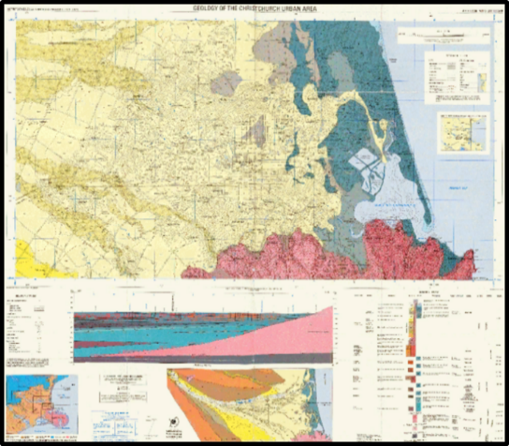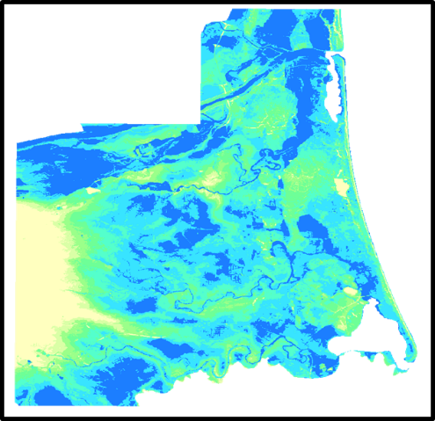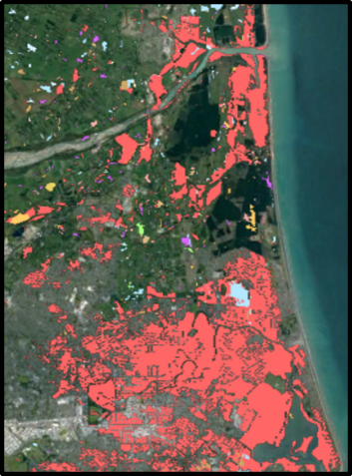

**Figure 1**. Geologic map of the Christchurch urban area (Brown and Weeber, 1992) **Figure 2**. Median water table depths of Christchurch, NZ. **Figure 3**. Observed liquefaction map following the September 4th 2010 and February 22nd 2011 earthquakes.

To begin the study, the following libraries were imported into a Jupyter Notebook running a Python 2.74 kernel: Matplotlib, Pykml and Python Imaging Library (PIL) were used to gather and extract information from the three maps. The maps were then downloaded as KMZ files from the New Zealand Geotechnical Database (NZGD) and viewed as Google Earth map overlays. Files that contained data that could be extracted were saved and read as KML files using Sublime Text 3. Files that did not contain extractable data in KML form, such as PNG files, were read using the PIL. One Jupyter Notebook contained three blocks of code that each performed a specific task that resulted in the complete data set.

4. **RESULTS.**

The results of the first block of code are an N × N grid of latitudinal and longitudinal coordinate pairs that serve as point of analysis for which future correlations will be associated with. To do so, variables were first assigned to initial and final latitude and longitude coordinates. The range of the values was then divided by an integer *N* that would increase over time to produce a smaller $∆r$ (change in latitude or longitude per integer) to produce a larger *N x N* grid. The list of coordinate pairs were saved as a NumPy array with dimensions N2 × 2 and uploaded to Google Earth Pro where they could serve as a visual representation.

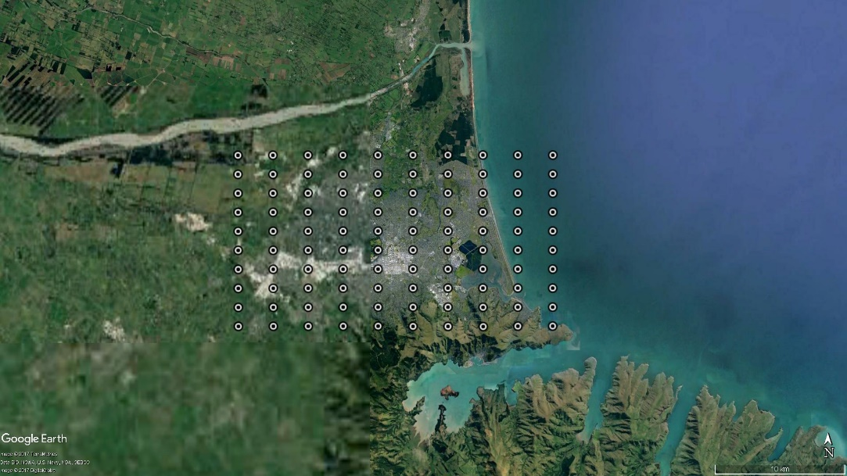

**Figure 4.** Google map image of *N x N* grid over the Christchurch urban area.

The second block of code parses the saved KML files and extracts the latitudinal and longitudinal coordinates that represent the perimeter of the liquefaction hazard map polygons. The path containing the coordinates were then reworked to delete unnecessary tabs, white space, converted into float points and split at each comma. Finally, the path was reshaped in an array containing a column for the X, Y and Z components of the coordinates and zipped into a list containing the X and Y coordinate pairs. The Z component was omitted due its constant value of zero. The third block of code combined the results of the previous two to create a list that checked liquefaction history of the list of points created. This was accomplished by taking a point and checking if it was located within the coordinate lists of the parsed KML files.

To read the two other maps, the python imaging library was used to extract the pixel colors from the respective PNG file. Each PNG houses its pixel data in a four band structure that is associated with a coordinate pair (x, y) that represents the width and the height of the file starting at the top left corner. Each coordinate then is associated with a color, defined by the values of (R, G, B, A) representing the colors red, green, blue and the aperture of the color. These colors then are used to determine the corresponding map unit for the geologic map of the Christchurch urban area or the value in meters for median water table depth. Together when combined with the liquefaction history results, the following data set is produced.



**Figure 5.** Finalized table segment of constructed data set. For each coordinate pair, a liquefaction history, ground water depth and geologic unit are assigned.

5. **DISCUSSION**

The compiled data set consists of a geographical position that is correlated to the liquefaction history, depth to water table and geologic map units for Christchurch, NZ. While this data has not yet been analyzed, there appears to be a qualitative trend in the data. It appears that the geologic units that are more likely to contain liquefiable sediments are alluvial sand and silt over bank deposits and sand, silt and peat of drained lagoons and estuaries. Liquefiable sediments were often located at sites that had a median water table depth of 0 – 3 meters below the ground surface.

6. **CONCLUSION**

Materials consisting of geologic and liquefaction maps as well as water table charts were used as the primary materials to derive quantifiable relationships. The Python programming language and associated libraries provided the tool set needed to extract information that was compiled into the data set. The data set provides the framework for further statistical analysis to be done, in order to determine the parameters that produce highest likelihood of liquefaction. Qualitative trends were observed from data, indicating further analysis is needed. A statistical analysis using linear regression and P-tests will be used to assess for wellness of fit for conclusions to be drawn. Following this analysis, this script may be used to test additional regions at threat of liquefaction in the Pacific Northwest using Shaker trucks.

7. **ACKNOWLEDGEMENT**

Financial support for this study was provided through the National Science Foundation under grants from the NHERI program (CMMI-1612144). Special thanks to the faculty and staff at the Department of Civil, Environmental, and Architectural Engineering at the University of Texas at Austin for their assistance in the development of this research topic. In particular, gratitude is owed to Dr. Patricia Clayton and Dr. Farnyuh Menq for their mentorship throughout the program. Thanks also goes to graduate students and staff at Univ. of Texas at Austin including Bench Zhang, Mr. Andy Valentine, and Mr. Robert Kent, as well as NHERI NCO at the University of Texas at San Antonio, in particular, Dr. Karina Vielma.

**BIBLIOGRAPHY**

Allen, J., Ashford, S., Bowman, E., Bradley, B., Cox, B., Cubrinovski, M., Green, R., Hutchinson, T., Kavazanjian, E., Orense, R., Pender, M., Quigley, M., and Wotherspoon, L., 2010. Geotechnical Reconnaissance of the 2010 Darfield (New Zealand) Earthquake, GEER Association Report No. GEER-024, ed. R. A. Green and M. Cubrinovski.

Brown, L.J. & Weeber, J.H. (1992), Geology of the Christchurch urban area. Scale 1:25000. Institute of Geological and Nuclear Sciences geological map 1. One sheet. Institute of Geological and Nuclear Sciences Limited, Lower Hutt, New Zealand.

Cubrinovski, M., Bray, J. D., Taylor, M., Giorgini, S., Bradley, B., Wotherspoon, L., and Zupan, J., 2011. Soil liquefaction effects in the central business district during the February 2011 Christchurch earthquake, Seismol. Res. Lett. 82, 893–904.

Forsyth, P.J., Barrell, D.J.A., Jongens, R. (2008) (compilers), Geology of the Christchurch Area, Institute of Geological and Nuclear Sciences 1:250 000 geological map 16. 1 sheet. Lower Hutt, New Zealand. GNS Science. ISBN 987-0-478-19649-8

Norris, R.J. and Cooper, A.F. (2001). Late Quaternary slip rates and slip partitioning on the Alpine Fault, New Zealand, J. Structural Geol., 23, 507– 520.

Review of liquefaction hazard information in eastern Canterbury, including Christchurch City and parts of Selwyn, Waimakariri and Hurunui Districts. Environment Canterbury Report R12/83. December 2012. Accessed 19 Feb 2013 from<http://ecan.govt.nz/advice/emergencies-and-hazard/earthquakes/Pages/liquefaction-information.aspx#review>