Quantifying Environmental Effects of Switching from Reinforced Concrete to Cross-Laminated Timber for Construction
Syed Ali Hasan

UC San Diego High Performance Outdoor Shake Table

Introduction
There is no question that one of the most important problems in the modern world is climate change. Greenhouse gas emissions have been steadily increasing over the years and undoubtedly contribute the most to this climate change. In their 2015 report, the Netherlands Environmental Assessment Agency stated that the global fossil-fuel and industrial processes carbon emission estimate was an enormous 35.7 billion tons of carbon dioxide in 2014. The building sector emitted about 9.4% of global greenhouse gas emissions in 2010 (Mastrandrea et al. 2015).
The US building sector constituted an even bigger percentage of US greenhouse gas emissions. The commercial and residential building sector emitted a combined total of 33% of U.S. greenhouse gases in 2010 per the EPA, approximately 18% of which came from the residential sector alone. These percentages include emissions from the manufacture of concrete and the energy required to heat and cool homes. There is an incredible amount of potential to reduce emissions and energy usage in this sector by simply rethinking the materials used to construct buildings.
There are many different materials that are used to construct various buildings. Traditionally, wood was used for low-rise residential buildings and reinforced concrete was used for mid/high-rise buildings. In the past twenty years, this has been changing. More and more research has been conducted, proving the viability of using timber for mid-rise buildings. Cross-laminated timber is an engineered material that has been gaining popularity in construction due to its many advantages over reinforced concrete. These advantages include its light weight, cost effectiveness, fast installation, and versatility. Its benefits also include better thermal performance which contributes to its environmental superiority by reducing emissions in the operations stage of a building’s life. These environmental benefits give CLT an enormous advantage over using reinforced concrete, which is traditionally seen as a huge source of emissions.
To determine the amount of energy used by a building throughout its life a method known as Life Cycle Assessment (LCA) is used. There are three main parts assessed in the life cycle of a building. The first is materialization. This consists of the actual construction of the building. The second is the operations stage. This is the stage where the building is used for the purpose it is designed for. The third and final stage is the end of life stage. This is when the building is demolished and its materials are properly disposed of. By analyzing the life cycle of two similar buildings, this research paper will compare the environmental effects of having CLT (cross-laminated timber) as the primary material used for construction as opposed to reinforced concrete (RC).

Methodology
This paper quantifies the environmental effects of switching from reinforced concrete to cross-laminated timber structures by using a method known as the LCA. This method analyzes the energy consumption of a building from its cradle to its grave in the three stages: materialization (embodied), operations (use), and end-of-life.
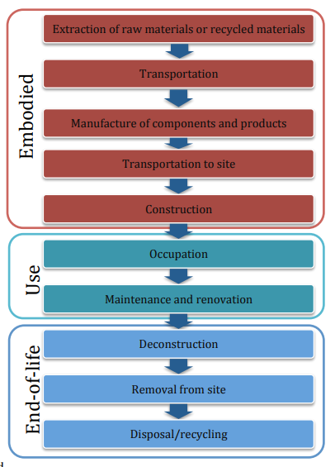
Figure 1: The different stages of assessment in an LCA. Obtained from Ghattas et al. [2013]
The LCA was performed on the midrise reinforced concrete building studied in Guo et al. [2017], shown in Figure 2. This was because operations stage simulations had already been performed on it and obtaining the operation’s stage energy usage on a different building would be incredibly complex and require a study of its own to get accurate results.
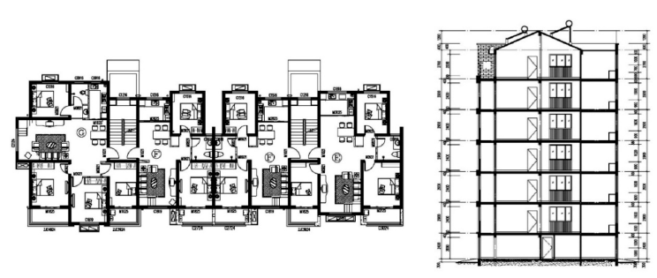
Figure 2: Floor plan and section view of building used in Guo et al. [2017].
Guo et al. [2017] performed the study by converting an existing RC (reinforced concrete) building to CLT and then performing simulations on it using IES (Integrated Environmental Solution) software. The strategy for making this conversion was not simply material replacement, but rather an integrated system build-up according to Guo et al. [2017] The specifics of this method are covered in depth in the paper’s methodology section.
This is a similar methodology to what was used in this study. The LCA was performed on both the CLT and RC versions of the structures. The results from each of the three stages were obtained for both. The data was then used to make a direct comparison between both versions of the buildings.
The first stage that was studied was the materialization stage of the LCA. The energy consumption from obtaining the selected building’s raw materials was observed. Then the use of energy in transporting the materials to the factory where they were manufactured were considered. The processes for the manufacture of the materials into its components and products were taken into account along with the energy required to transport these products to the site. Since this distance varied across cities, a distance of 186 miles was assumed for simplicity. Finally, the energy used in the construction of the buildings was considered. Since CLT stores carbon dioxide within itself, carbon sequestration was considered in this stage. Assuming 1 cubic meter of CLT stores 800 kilograms of carbon dioxide, 673.76 tons of carbon dioxide were subtracted from the materialization stage (842.2 m^3 of CLT was used in this building).
In the operations stage, only the consumption due to the actual occupation of the building was considered. This was because maintenance/renovations make insignificant contributions in this stage overall. Despite there only being one sub factor to consider in this stage, it is still the most important one in a structure’s life. As shown in Figure 3, energy consumption during the actual use of a building is the most contributive stage in energy consumption.

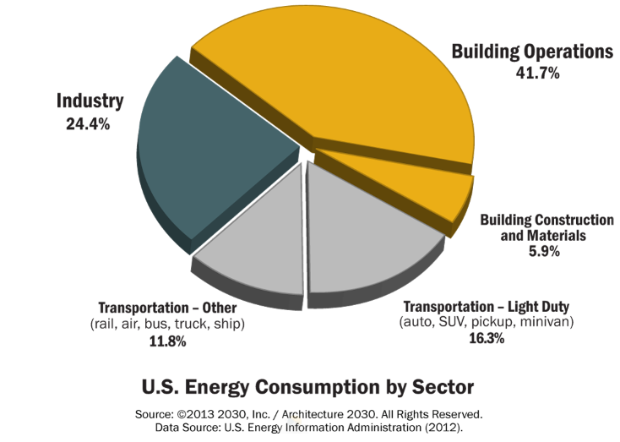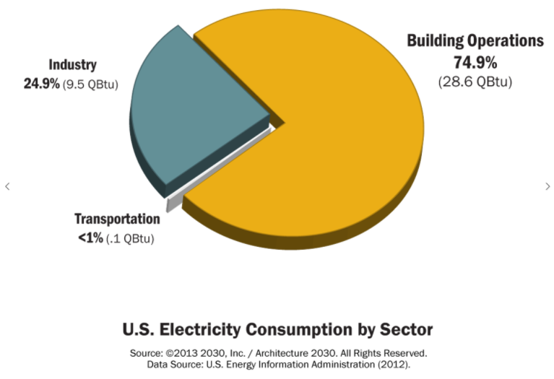
Figure 3: U.S. Energy and Electricity Consumption by Sector
To get an accurate measurement of the amount of energy used for heating and electricity, results from Guo et al. [2017] were used. The study was performed by converting an existing RC (reinforced concrete) building to CLT and then performing simulations on it using IES (Integrated Environmental Solution) software. The strategy for making this conversion was not simply material replacement, but rather an integrated system build-up according to Guo et al. [2017].
The simulations were performed in 31 different Chinese cities that ranged over various climate zones. The buildings’ designs were adjusted to meet local building regulations. The specifics of this method are covered in depth in the paper’s methodology section. Since the only differing factor between performing these simulations in China compared to the US was weather, the data from these cities was applied to US cities by determining which one of these had the most similar weather from 2016. The data to perform this comparison was taken from Weather Underground’s historical weather database.

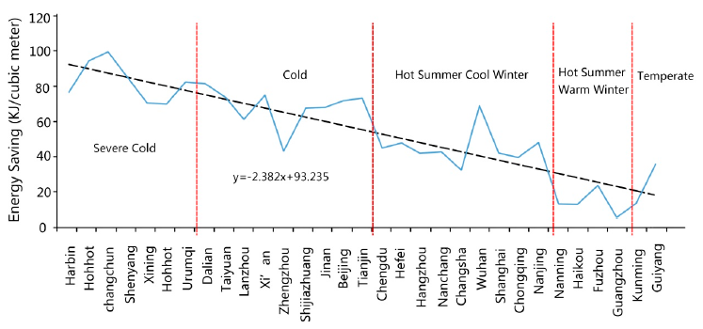
Figure 4: Operations stage energy usage in 31 Chinese cities. Taken from Liu et al. [2015].
The end-of-life stage was broken down into three parts. The first was the deconstruction of the structure. The deconstruction of a building is assumed to take 90% of the energy it took to erect it. The second was the removal of the materials from the site. This is uses an insignificant amount of energy in an LCA so it was not taken into account. The third and most important part was the disposal/recycling of the materials. Most of the carbon emissions in the end of life stage are related to the disposal of materials so this is the part that was most heavily focused on.
Results
The materialization energy values associated with the two versions of the buildings was covered in Liu et al. [2016]. With an assumed distance of 186 miles for transportation, the energy required for the materialization of the concrete structure was 4000 GJ. The materialization of the CLT structure was approximately 2000 GJ on the other hand. The CO2 emissions ratios were even larger than the energy consumption ratios. The erection of the concrete structure emitted 400 tons of CO2 whereas the CLT approximately emitted 125 tons.
The operations stage is where most of the variables change. Since the previously cited studies were done in China, the energy simulations used weather data from Chinese climate zones. As a result, the simulation data could not be directly translated to suit US based studies. In an effort to provide a better comparison, 10 evenly dispersed US cities were categorized into the five climate zones studied in Guo et al. [2017] using the criteria specified in that paper. They were then matched with their Chinese counterparts using weather data. The cities’ locations are shown in Figure 5 and the operations data is shown in Figure 6.
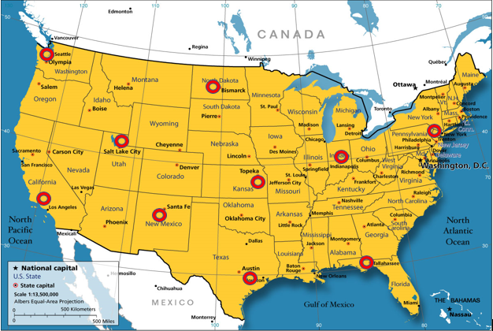

Figure 5: locations of the 10 cities studied for operations stage energy usage. These cities are: Seattle, Los Angeles, Salt Lake City, Santa Fe, Bismarck, Topeka, Austin, Indianapolis, Tallahassee, New York City.

Figure 6: Energy consumption and carbon emissions during operation’s stage per year.
As shown in Figure 6, emissions and consumption during the operation’s stage of a building depends on the location of it. The cross-laminated timber version of the building always used less energy and emitted less CO2 than the reinforced concrete version regardless of the climate zone. The average for the difference in consumption and difference in emissions was 43.5 MJ/m^2 and 4 KG/m^2 respectively. Since the building’s net internal floor area is 2799.3 m^2, 121.77 GJ and 11.2 tons of CO2 can be saved per year. If the building’s life is assumed to be 50 years, an average of 559.86 tons of CO2 and 6088.5 GJ of energy can be saved throughout its lifecycle.
The end-of-life stage also showed the superiority of CLT for the environment. For the deconstruction/removal part of this stage, CLT structures required about 700 GJ as compared to concrete’s 1000 GJ. For the CO2 emissions, CLT structures required 100 tons versus concrete’s 250 tons (Liu et al. 2015). When taking disposal into account, the numbers were even more impressive. The CLT in the structure can either be recycled or used as biofuel. This study assumes 45% of it was used as biofuel and 55% was recycled. Liu et al. [2015] concluded that the energy recovery from using 45% of the CLT as biofuel was 4000 GJ. The study also determined that with a 55% recycle ratio, 606.24 tons of CO2 could be reduced.

Figure 7: A comparison of energy consumption between concrete and cross-laminated timber buildings throughout their life cycles.

Figure 8: A comparison of carbon dioxide emissions between concrete and cross-laminated timber buildings throughout their lifecycles.
As shown in Figures 7 & 8, the CLT version was undoubtedly more environmentally friendly than its concrete counterpart. An average of the difference in energy consumption in the ten cities showed 12387.81 GJ could be saved. Additionally, 1591.03 tons of CO2 can be reduced according to this data.
Discussion
On average, the CLT versions came out to require 48% of the energy that the concrete versions required. They also saved 54% of the carbon dioxide emitted from their reinforced concrete counterparts. This figure is slightly lower than the results obtained in Darby et al. [2013] which reported that 61% of carbon emissions can be reduced when using CLT for multi-story residential buildings as opposed to concrete. On the other hand, Liu et al. [2015] arrived at the conclusion that 34% energy consumption would be saved and 44% carbon emissions would be reduced. These deviations could be due to a variety of factors including different sizes of the buildings, simulated weather conditions, etc.

Figure 9: CLT building emissions and energy consumptions as percentages of the reinforced concrete versions.
Due to these variations in the results of different studies done on the same topic, it would be helpful to keep conducting them with varying factors. It would be interesting to see exactly how much the results from a life cycle assessment would differ with a taller building as compared to a shorter one. Conducting LCA’s with weather conditions taken from different parts of the world or changing the recycling ratios would be very useful as well.
One of the things to consider in this study is the transportation distance. There is only one CLT factory in the U.S., and it is located in Oregon so the transportation distance of 183 miles is not entirely accurate. CLT construction is still extremely new in the U.S. so setting a distance according to that one factory would not be fair either. As CLT construction increases over time, so will the number of factories. The transportation distance will keep changing so there was not a correct distance that could be set.
Another thing to consider is the renovations/maintenance of the building in its 50 year life cycle. This was not taken into account for this paper since the simulation software used is limited in this aspect. It only simulated the data from everyday use of the building and did not consider any renovations that would occur to maintain the building. In future studies, energy consumption and carbon emissions for this part of the operations stage would provide for a more complete assessment.

References
Darby, H.J., A.A. Almualim, and F. Kelly. "A Case Study to Investigate the Life Cycle Carbon Emissions and Carbon Storage Capacity of a Cross Laminated Timber, Multi-story Residential Building." A Case Study to Investigate the Life Cycle Carbon Emissions and Carbon Storage Capacity of a Cross Laminated Timber, Multi-story Residential Building. N.p., 10 Sept. 2013. Web. 8 Aug. 2017.
Ghattas, Randa, Jeremy Gregory, Elsa Olivetti, and Suzanne Greene. "Concrete Sustainability Hub." Life Cycle Assessment for Residential Buildings: A Literature Review and Gap Analysis | Concrete Sustainability Hub. N.p., 12 Mar. 2013. Web. 08 Aug. 2017.
Guo, H., Liu, Y., Chang, W.-S., Shao, Y. & Sun, C. Energy Saving and Carbon Reduction in the Operation Stage of Cross Laminated Timber Residential Buildings in China. Sustainability (2017). doi:10.3390/su9020292
"Historical Weather." Weather Underground. N.p., n.d. Web. 27 July 2017.
"INTERNATIONAL ENERGY OUTLOOK 2016." U.S Energy Information Administration. U.S Energy Information Administration, 11 May 2016. Web. 27 July 2017.
K Intergovernmental Panel on Climate Change (IPCC). Chapter 9: Buildings. In Intergovernmental Panel on Climate Change. Climate Change 2014: Mitigation of Climate Change; IPCC: Geneva, Switzerland, 2014.
Liu, Ying, Haibo Guo, Cheng Sun, and Wen-Shao Chang. "Assessing Cross Laminated Timber (CLT) as an Alternative Material for Mid-Rise Residential Buildings in Cold Regions in China—A Life-Cycle Assessment Approach." Research Gate. N.p., 18 Oct. 2016. Web. 26 July 2017.
Mastrandrea, M.D., et al. “Climate Change 2014 Synthesis Report.” Intergovernmental Panel on Climate Change, Intergovernmental Panel on Climate Change, 2015, www.ipcc.ch/pdf/assessment-report/ar5/syr/AR5_SYR_FINAL_All_Topics.pdf.
Olivier, Jos G.J., et al. “Trends in Global CO2 Emissions: 2015 Report.” edgar.jrc.ec.europa.eu/news_docs/jrc-2015-trends-in-global-co2-emissions-2015-report-98184.pdf.
"Sources of Greenhouse Gas Emissions." EPA. Environmental Protection Agency, 14 Apr. 2017. Web. 30 July 2017.
“U.S. Energy Information Administration - EIA - Independent Statistics and Analysis.” International Energy Outlook 2016-World Energy Demand and Economic Outlook - Energy Information Administration, U.S. Energy Information Administration, 11 May 2016,

