Creation of a wave experiment Data Accessing tool in DesignSafe-CI

Olajide Ogunmola
Research Site: Texas Advanced Computing Center at UT Austin
Abstract
An experiment was conducted at Oregon State University to study how two large cylinders would react when subjected to wave impacts. The waves were generated in a wave basin and were made to come in collision with two large cylinders with 10 sensors located around the cylinders. The purpose of the experiment was to map what forces a wave would have on a cylindrical object; in other words, what shape would it take and how much force will it exert on the critical parts of a sturdy, hollow, and cylindrical structure. The waves were meant to mimic the waves generated by a storm surge during a hurricane, and the cylinders were meant to mimic fuel tanks used to store petro-chemicals. The second part of this experiment involves doing data curation, describing and organizing the data taken from the experiments.

Introduction
The objective of this experiment is to be able to successfully recreate the forces of a storm surge on a petro-chemical fuel tank. This experiment is meant to shed light into what happens to a fuel tank during a large storm, and help people build fuel tanks that can withstand storm surge forces much more effectively as to prevent spillage disasters during these events. At the TACC our specific objective is to gather all of the data and metadata, and then curate that data. We want to describe and organize the data so that other researchers can look at the data, and we want to create an interactive simulation tool for researchers to use as well.

Discussion
We are testing wave impact on cylindrical structures. By using a model wave surge we will be able to measure the range of surge elevations and wave heights. Three types of waves will be tested on the cylindrical structures which are supposed to represent fuel tanks. Using up to 10 sensors we will measure the pressure around these tanks. Force, velocity, wave height and other aspects will be taken into account. The test is not set up to damage the cylinders but instead to measure and collect data about the wave and arrange them in a way to be easily interpreted. The sensors are placed in different areas of the structures and they measure data on different time logs. We then take this data and arrange it in a way that shows what is happening at certain times on several locations around the cylindrical structures. There over 5000 data files for the ten sensors which hold different time series of data that will all be used to create a sensor sketch. We will be presenting a code that takes the wave impact data and integrates it across sensors to get a source. Then finally we will be presenting the aggregate data for all the sensors.
Directional Wave Basin

Method
Using the designsafe-CI interface we were able to categorize the data as shown in figure 3. We structured the data splitting it into three categories, model configuration, sensor data then events. After categorizing this data, we then needed to make an interface that would sort this data making it easy to access and use. As shown in figure 4, the interface we made was a select widget function on python. This widget could also plot the data as shown in figure 5.
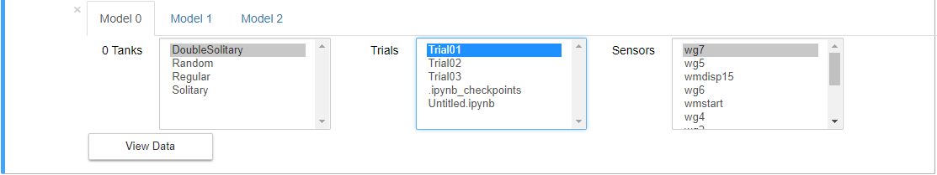
figure 4
figure 5
figure 3

Results
The results of our project are shown above in figures 3, 4 and 5. Moreover, our interface/tool can be used to categorize and access any kind of data. Our project is essentially structuring data for later use. Once we finish our work with the data curation other organizations can use our data as source for scaling. They can simulate the data and put different conditions on it. For example, they could simulate the data to find the limit of the cylindrical structures and test different wave possibilities of different types of structures. This way they can build fuel tanks that can sustain storm surges without collapsing.

Acknowledgement
- Natural Hazards Engineering Research Infrastructure (NHERI)
- Mentos
  - Dr. Maria Esteva, Dr. Charlie Dey
- Principal Investigators
  - Dr. Jamie Padgett and Dr.Clint Dawson
- Mrs. Kerina Vielmas

